EASTWOOD UNITING CHURCH - ENGLISH CLASSES
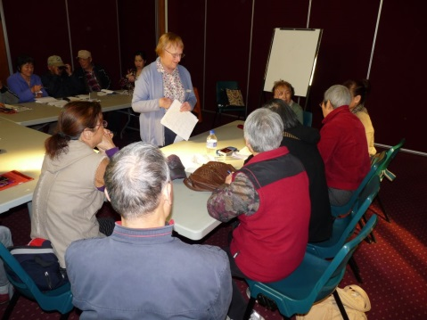
Eastwood Uniting Church (EUC) conducts English classes to hold out the hand of friendship and to offer assistance with English language to people from non-English speaking background who have come to live in our community.
The church welcomes participation by people from the community who volunteer to be teachers or helpers, and who share this aim.

The church supports the classes by providing space in its property, photocopying facilities, and a budget for purchase of resources & other needed items, and to subsidise participation in teacher training.

Volunteer teachers & helpers are covered by an Insurance Policy of the Uniting Church. They should be recorded as volunteers, and sign in each day they are present at the classes.

Monday morning classes begin at 9.30am and finish at 11am. An invitation is made at the beginning of each term for a voluntary donation of $5. Classes are not held in the (public) school holidays. Students are assessed and graded on their first day of attendance, although their class allocation may need to be changed later.

Students normally go directly to their class, except on the first and last day of each term, when a short time is held with everyone in the hall, for announcements, and for a sense of being part of the larger community of all students, teachers & helpers.

The lead teacher, in consultation with the teaching team for each class, is responsible to plan the teaching program for that class. The team is also responsible to keep a roll of students, noting attendance and totals for each week. At the end of each term please give a copy of the roll and attendance record, with average class attendance for the term, to one of the co-ordinators (Marion & Val – see below).

A meeting of teachers, including a training session, is held on the ‘pupil free day’ at the beginning of 2nd and 3rd term.

Parking On Monday mornings the car park under the church is available to volunteers at the English classes, but not to students. If you wish to use the car park you need to display a laminated sign on your dashboard. Ask Marion for one of these signs.

Monday morning ‘English and Bible Class’ – to learn more English and learn about Jesus and the Bible. Optional additional classes held on Monday mornings, 11.15am – 12.15pm.
Tuesday evening classes begin at 7.30pm and finish at 9pm. They are held weekly, except for school holidays. Classes are graded.
Friday morning class for beginners 10am – 11.30am
During times when church premises are closed online classes are arranged.
Co-ordinators who are church members provide the point of contact with the Church Council and co-ordinate classes, teachers & general arrangements.

The Co-ordinators for Monday morning classes are Marion Gledhill (9874 2088, or 0423355759) and Val Bird (9801 0928, or 0402143825). Malcolm Gledhill co-ordinates the Tuesday evening classes (98742088 or 0401301388).

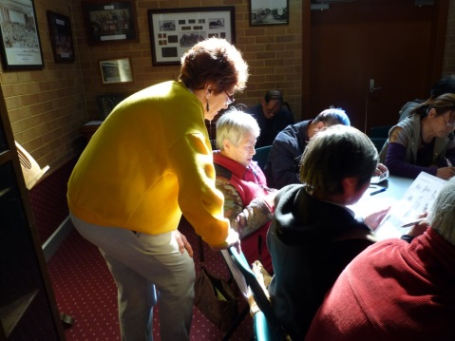
Resource material is kept in a large plastic box in the storage room, marked as ‘EUC ESL’. Teachers are asked to complete the ‘Library borrowing book’ whenever they borrow or return a book or other resource.

Training. Teachers are encouraged to use training opportunities as they may be available, also to read training material available from Co-ordinators.

Expectations of volunteer teachers and helpers – that you will:
- share the aim of the classes “to hold out the hand of friendship and to offer assistance with English language to people from non-English speaking background who have come to live in our community”.
- work as part of a team, co-operating with other teachers and helpers in planning lessons and other activities
- come early and assist to set-up classrooms
- treat students and other teachers & helpers with respect
- meet with other teachers and helpers when meetings are arranged, usually once a term
- make suggestions and share your knowledge & ideas about resources and ways for classes to become more effective
- act in accordance with any directions from Co-ordinator
- see that a record of student attendance is kept each week, and supply this information to the Co-ordinators at the end of each term.
- speak to a Co-ordinator about any student needs of a personal nature that go beyond ‘the everyday’, so that further assistance or appropriate referral may be offered
- speak to a Co-ordinator about any concerns you may have about personnel or any other aspect of the English classes.

First Aid
A box can be found on the wall of the servery annexe to the kitchen.

Photocopying may be done on the church copier, in a small room behind the office. Please ask Co-ordinator for PIN number. This can then be used to copy in black and white. If you require colour copies please ask Co-ordinator or office secretary to copy this for you.

CONTACT for church:
Church Office (9am to 3pm, Tuesday-Friday) Ph 9858 5732, or secretary@euc.org.au .
Eastwood Uniting Church is on the corner of Lakeside Rd and Hillview Rd Eastwood. It is close to Eastwood railway station. If you come by car, there is parking under the church - enter from Hillview Rd.
Postal address: PO Box 324 Eastwood NSW 2122
. 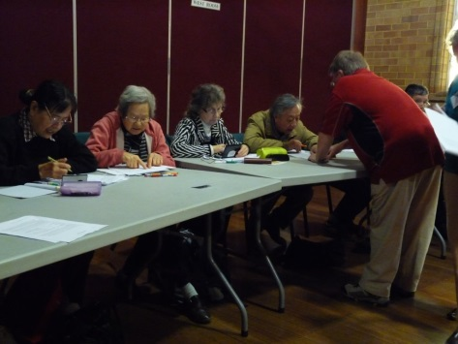

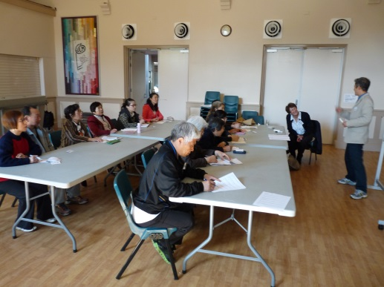

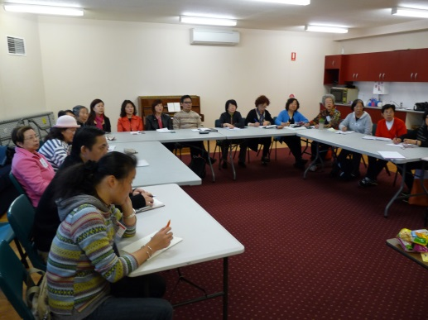

Dated: July, 2021.

