The Committal
[the family regathers at Macquarie Park]

What no eye has seen, nor ear heard, nor the human heart conceived,
God has prepared for those who love him. [1 Corinthians 2:9]

The Committal

Blessing
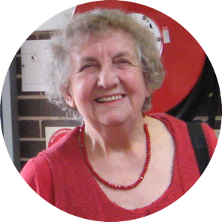

A Prayer for those at home and online.

Merciful and gracious God,
we give thanks for the life of your daughter, Yvonne.
We pray for her family and friends in their time of mourning,
especially her children Warwick, Leonie and Chris,
and grandchildren Annabel, Hayley, Hugh, Kiara, Sam, Sophie and Tamara.
May you comfort them and be present
in their conversations and memories.

At Eastwood, we will remember Yvonne and John
as companions with us on the journey.
We are grateful for Yvonne’s generous contribution
to the life of this community and ask your blessing on her spirit. Amen.

Thanks to Janine and Michelle for technical support.

A Service
celebrating the life of

Yvonne van Ede

5 January 1939 – 30 September 2021

‘Come to me all you that are weary and are carrying heavy burdens,
and I will give you rest.’ – Matthew 11:28
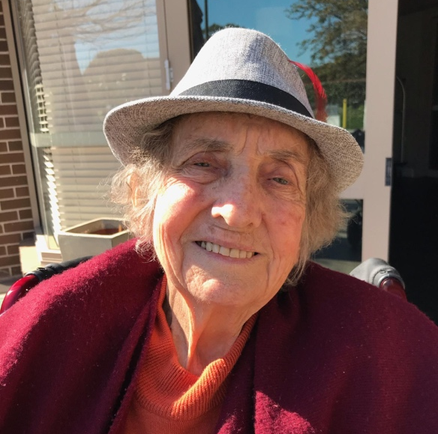

12.30pm at Eastwood Uniting Church,
followed by 2.15pm, the Rose Chapel,
Macquarie Park Crematorium

Wednesday 6th October, 2021

The Service of Remembrance and Thanksgiving
Welcome Rev Dr Amelia Koh-Butler [Eastwood Uniting Church]
Prayer
Hymn [Lyngham] O for a thousand tongues to sing
my dear Redeemer's praise,
the glories of my God and King,
the triumphs of his grace!

Jesus! the name that charms our fears,
that bids our sorrows cease,
'tis music in the sinner's ears,
'tis life and health and peace.

He speaks and listening to his voice
new life the dead receive
the mournful, broken hearts rejoice
the humble poor believe.

My gracious Master and my God
assist me to proclaim to spread
through all the earth abroad
the honours of thy name. – Charles Wesley

Words of Remembrance Warwick van Ede Chris van Ede Sophie and Hugh van Ede
Words from Scripture - Psalm 90 Leonie Walker
Words of Comfort and Hope Rev Amelia

Prayers Our Father in heaven, hallowed be your name,
your kingdom come, your will be done,
on earth as in heaven. Give us today our daily bread.
Forgive us our sins as we forgive those who sin against us.
Save us from the time of trial and deliver us from evil.
For the kingdom, the power,
and the glory are yours now and forever. Amen.

Commendation

Hymn [Sagina] And can it be that I should gain
An interest in the Saviour’s blood?
Died he for me, who caused his pain?
For me, who him to death pursued?
Amazing love! how can it be
That thou, my God, should die for me?

He left his Father's throne above,
So free, so infinite His grace;
Emptied himself of all but love,
And bled for Adam's helpless race;
'Tis mercy all, immense and free;
For, O my God, it found out me.

Long my imprisoned spirit lay
Fast bound in sin and nature's night;
Thine eye diffused a quickening ray,
I woke, the dungeon flamed with light;
My chains fell off, my heart was free;
I rose, went forth and followed Thee.

No condemnation now I dread
Jesus, and all in Him is mine!
Alive in Him, my living Head,
And clothed in righteousness divine,
Bold I approach the eternal throne,
And claim the crown, through Christ my own.
– Charles Wesley

This concludes the Service in the Church.

