Sunday – August 20 2023 Eastwood Uniting Church
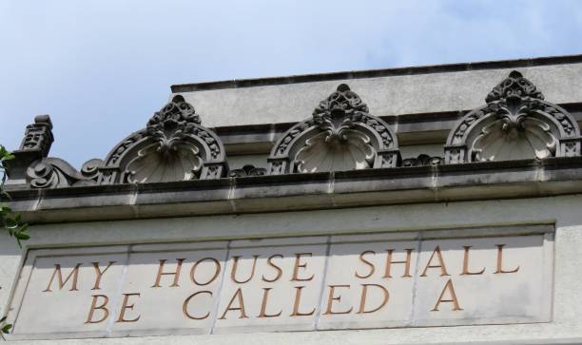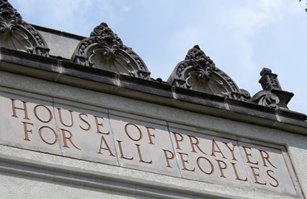

Welcome 歡迎 어서오세요
G’day and Welcome Warami mittigar! [Darug]
환영합니다 [Korean] 欢迎 致谢 – 神的土地 [Chinese]
Hej kompis [Swedish] Guten Tag, Freund [German] Ciao amico [Italian]
歡迎大家今天來到伊士活聯合教會參加八月二十日的主日崇拜

Lighting the Christ Candle 환영과 그리스도의 촛불 켜기 燃點基督之燭
Acknowledgement of the First People of This Land 이 땅의 원주민 인정 致謝這土地的的原住民

We acknowledge the Wallumedegal people of Darug country, first inhabitants of this place, and for the way they have cared for this land since time immemorial.

We recognise their continuing connection to land, waters and culture. We honour their Elders past, and present, and pray that we may all work together for reconciliation and justice in this nation.

우리는 다룩 그룹에 속한 월러메드걸 사람들이 이 곳의 원주민이라는 것과 그들이 이 땅을 태고적부터 그들의 방법으로 보호하고 가꾸어 온 것을 인정합니다. 우리는 이들이 지속적으로 이 땅과 강과 바다, 문화와 깊이 연결되어 있슴을 알고 있습니다. 우리는 그들의 과거와 현재의 지도자들을 존중하며 이 땅에 화해와 정의가 속히 이루어지도록 모두 함께 노력할 것을 기도합니다.

我們感謝 Darug 國家的 Wallumedegal 人，他們是這個地方的原住民，感謝他們自遠古以來照料這片土地的方式。

我們承認他們與土地、水域和文化的持續聯繫。 我們向他們過去和現在的長老致敬，並祈禱我們可以共同為這個國家的和解與公義而努力。

Call to Worship 예배로의 부름 宣召崇拜 Psalm 67: 3-7 詩篇 67:3-7

³ May the peoples praise you, God; may all the peoples praise you.
⁴ May the nations be glad and sing for joy, for you rule the peoples with equity and guide the nations of the earth.
⁵ May the peoples praise you, God; may all the peoples praise you.
⁶ The land yields its harvest; God, our God, blesses us.
⁷ May God bless us still, so that all the ends of the earth will fear him.

³ 神啊，願萬民稱謝你！願萬民都稱謝你！
⁴ 願萬族都快樂歡呼；因為你必按公正審判萬民，引導地上的萬族。
⁵ 神啊，願萬民稱謝你！願萬民都稱謝你！
⁶ 地已經出了土產， 神，我們的 神，要賜福給我們。
⁷ 神要賜福給我們，地的四極都要敬畏他！

Hymn 詩歌: Hallelujah - Performed by The United States Air Force Band's Singing Sergeants
https://www.youtube.com/watch?v=oU_Ru13cY_g&list=RDbJGe6PcNvYU&index=3
哈利路亞
你经过的所有失落
我也曾经一样走过
但你不知能向谁诉说 是否
灵魂深处 微小声音
有回答 更有呼唤
你活着的每一口呼吸 哈利路亚
哈利路亚 哈利路亚 哈利路亚 哈利路亚
请原谅我给的不多
尽我所有请你接受
在祂面前才学会为你 祈求
愿你记得 美好生命
要自由 更要赞美
我唇上已无他语 哈利路亚
哈利路亚 哈利路亚
爱声声藏在传说中
那是君王为祂而弹奏
但你从不曾在意听过 是否
他是这样走 有笑有泪
有刚强 也有软弱
千百年唱着困惑 哈利路亚
你和祂之间若即若离
你孤独走在旷野里
月光美丽无法抵抗 是否
爱的试探 有苦有痛
有毁灭 更有背叛
这是冰冷破碎旋律 哈利路亚
哈利路亚 哈利路亚 哈利路亚 哈利路亚

Call to confession 참회 기도 認罪邀請：
Our hearts long for God, and we know we fall short of God’s glory, so let us now confess to God the ways we have individually and collectively fallen short of God’s Grace.
我們的心渴望上帝，我們知道我們虧缺了上帝的榮耀，所以現在讓我們向上帝承認我們個人和集體都虧缺了上帝的恩典。
Assurance 용서의 확신 確據：
The God of David, the father of Jesus knows all that we are. In God’s love and grace we know that we are indeed cleansed from all our sin, and sustained by the Spirit. In the name of Jesus Christ, God’s ultimate sacrifice, we are forgiven.
大衛的上帝，耶穌的父親知道我們的一切，在上帝的愛和恩典裡，我們知道我們已被潔淨，並靠著聖靈持守。因著耶穌基督的聖名，上帝最終的犧牲，我們已被赦免。
Thanks be to God! 하나님께 감사드립니다. 感謝上帝
Peace 평화 平安禮：
Knowing that we might find peace in God’s presence and love, let us share Christ’s peace with one another…the peace of Christ be with you all.
知道我們可以在上帝的同在和愛中找到平安，讓我們彼此分享基督的平安。願基督的平安與你們大家同在。
Announcements 공고 報告
Chinese depart for worship 中文堂會友請前往舊禮堂繼續崇拜
중국 성도들은 이제 예배당을 나갑니다.
Bible Reading성경봉독 Isaiah 56:1, 6-8 Liz Moran
¹ Thus says the Lord:
Maintain justice, and do what is right,
for soon my salvation will come,
and my deliverance be revealed.
⁶ And the foreigners who join themselves to the Lord,
to minister to him, to love the name of the Lord,
and to be his servants,
all who keep the sabbath, and do not profane it,
and hold fast my covenant—
⁷ these I will bring to my holy mountain,
and make them joyful in my house of prayer;
their burnt-offerings and their sacrifices
will be accepted on my altar;
for my house shall be called a house of prayer
for all peoples.
⁸ Thus says the Lord God,
who gathers the outcasts of Israel,
I will gather others to them
besides those already gathered.

In this is the word of the Lord,
Thanks be to God. 하나님께 감사 感谢上帝
Message 설교 ‘Inclusiveness’ Chris Wakefield

Hymn: Be Thou My Vision - Audrey Assad https://www.youtube.com/watch?v=Optrm7lF16s

Be thou my vision, O Lord of my heart;
naught be all else to me, save that thou art
thou my best thought, by day or by night,
waking or sleeping, thy presence my light.

Be thou my wisdom, and thou my true word;
I ever with thee and thou with me, Lord;
thou my great Father, I thy true son;
thou in me dwelling, and I with thee one.

Riches I heed not, nor man’s empty praise,
thou mine inheritance, now and always:
thou and thou only, first in my heart,
high King of heaven, my treasure thou art.
High King of heaven, my victory won,
may I reach heaven’s joys, O bright heaven’s Sun!
Heart of my own heart, whatever befall,
still be my vision, O ruler of all.

Gaelic c 8th Century tr Mary Elizabeth Byrne 1880-1931
Versified by Eleanor Henrietta Hull 1860-1935
Words from the Poem Book of the Gael by permission Chatto & Windus, London.

Prayers of People 중보기도 Michelle Loxton

Offering & Prayer of Dedication 헌금기도
Your generosity, grace, and mercy are astounding, and we pray that the gifts we offer in worship and throughout the week might be used in your name. Help us to be generous with our money, but also with our talents and time. Strengthen us to recognise your blessings, to be grateful, and to respond accordingly.

Blessing 축도
Psalm 67: 1-2
¹ May God be gracious to us and bless us
and make his face to shine upon us,
² that your way may be known upon earth,
your saving power among all nations.

Blessing Song: Amazing Gospel Flash Mob -- Let's Mob the Streets for Jesus

https://www.youtube.com/watch?v=bJGe6PcNvYU&list=RDbJGe6PcNvYU&start_radio=1

"Every Praise Is To Our God." Hallelujah!!!

Please join us for Morning Tea

