Sunday – September 3 2023 Eastwood Uniting Church

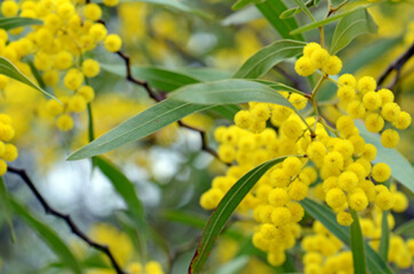

Welcome 歡迎 어서오세요
G’day and Welcome Warami mittigar! [Darug] 환영합니다 [Korean] 欢迎 [Chinese]
Hej kompis [Swedish] Guten Tag, Freund [German] Ciao amico [Italian]
Lighting the Christ Candle 환영과 그리스도의 촛불 켜기 燃點基督之燭

Acknowledgement of the First People of This Land 이 땅의 원주민 인정 致謝這土地的的原住民

We acknowledge the Wallumedegal people of Darug country, first inhabitants of this place, and for the way they have cared for this land since time immemorial.

We recognise their continuing connection to land, waters and culture. We honour their Elders past, and present, and pray that we may all work together for reconciliation and justice in this nation.

우리는 다룩 그룹에 속한 월러메드걸 사람들이 이 곳의 원주민이라는 것과 그들이 이 땅을 태고적부터 그들의 방법으로 보호하고 가꾸어 온 것을 인정합니다. 우리는 이들이 지속적으로 이 땅과 강과 바다, 문화와 깊이 연결되어 있슴을 알고 있습니다. 우리는 그들의 과거와 현재의 지도자들을 존중하며 이 땅에 화해와 정의가 속히 이루어지도록 모두 함께 노력할 것을 기도합니다.

我們感謝 Darug 國家的 Wallumedegal 人，他們是這個地方的原住民，感謝他們自遠古以來照料這片土地的方式。

我們承認他們與土地、水域和文化的持續聯繫。 我們向他們過去和現在的長老致敬，並祈禱我們可以共同為這個國家的和解與公義而努力。

Call to Worship 예배로의 부름 宣召崇拜
Praise be to God Praise be to God for the gift of life
Praise be to God for the gift of death Praise God for the gift of hope
But, above all else,
Praise God for the gift of love in which life and death and hope are intermingled.
Praise be to God. Amen!

하나님께 찬양을 드리라 생명의 선물을 주신 하나님께 찬양을
죽음의 선물을 주신 하나님을 찬양하라 소망의 선물을 주신 하나님을 찬양하라
그러나 무엇보다 생명과 죽음 그리고 소망이 어우러진 그 분의 선물을 찬양하라
하나님께 찬양을 드리라 아멘!

讚美上帝 讚美上帝賜予生命的禮物
讚美上帝賜予死亡的禮物 讚美上帝賜予盼望的禮物
但是，最重要的是，讚美上帝賜予生命、死亡和盼望交織在一起的愛的禮物。
讚美上帝 阿們！

Hymn 찬송가 詩歌: Christ, be our light 우리의 빛이신 예수 그리스도 基督是光 AOV2: 3

Prayer of Confession & Assurance of Forgiveness회개기도와 용서의 확신
認罪禱告和赦罪確據
Thanks be to God! 하나님께 감사드립니다. 感謝上帝

Children’s Story: Old Turtle https://youtu.be/Um5VYcYCkf8?si=GIrrt3lvDSw1zzjK
Announcements 공고 報告
Hymn 찬송가 詩歌: We are called 우리는 부름받았습니다 AOV 2: 60

Chinese depart for worship 中文堂會友請前往舊禮堂繼續崇拜
중국 성도들은 이제 예배당을 나갑니다.
Bible Readings 성경봉독 Trevor Bird
Romans 12:9-21
⁹ Let love be genuine; hate what is evil, hold fast to what is good; ¹⁰ love one another with mutual affection; outdo one another in showing honour. ¹¹ Do not lag in zeal, be ardent in spirit, serve the Lord. ¹² Rejoice in hope, be patient in suffering, persevere in prayer. ¹³ Contribute to the needs of the saints; extend hospitality to strangers.
¹⁴ Bless those who persecute you; bless and do not curse them. ¹⁵ Rejoice with those who rejoice, weep with those who weep. ¹⁶ Live in harmony with one another; do not be haughty, but associate with the lowly; do not claim to be wiser than you are. ¹⁷ Do not repay anyone evil for evil, but take thought for what is noble in the sight of all. ¹⁸ If it is possible, so far as it depends on you, live peaceably with all.
¹⁹ Beloved, never avenge yourselves, but leave room for the wrath of God; for it is written, ‘Vengeance is mine, I will repay, says the Lord.’ ²⁰ No, ‘if your enemies are hungry, feed them; if they are thirsty, give them something to drink; for by doing this you will heap burning coals on their heads.’ ²¹ Do not be overcome by evil, but overcome evil with good.
Matthew 16:21-28 로마서 마태복음
²¹ From that time on, Jesus began to show his disciples that he must go to Jerusalem and undergo great suffering at the hands of the elders and chief priests and scribes, and be killed, and on the third day be raised. ²² And Peter took him aside and began to rebuke him, saying, ‘God forbid it, Lord! This must never happen to you.’ ²³ But he turned and said to Peter, ‘Get behind me, Satan! You are a stumbling-block to me; for you are setting your mind not on divine things but on human things.’
²⁴ Then Jesus told his disciples, ‘If any want to become my followers, let them deny themselves and take up their cross and follow me. ²⁵ For those who want to save their life will lose it, and those who lose their life for my sake will find it. ²⁶ For what will it profit them if they gain the whole world but forfeit their life? Or what will they give in return for their life?
²⁷ ‘For the Son of Man is to come with his angels in the glory of his Father, and then he will repay everyone for what has been done. ²⁸ Truly I tell you, there are some standing here who will not taste death before they see the Son of Man coming in his kingdom.’
In this is the word of the Lord,
Thanks be to God. 하나님께 감사 感谢上帝

Message 설교

Prayers of People 중보기도 Brian Grant

Offering & Prayer of Dedication 헌금기도
Hymn 찬송가 : The Summons ATOK 413

Blessing 축도
Go into this week,
blessed by the holiness of God and holding fast to what is good,
inspired by the genuine love of Jesus Christ and loving what is good
strengthened by the Holy Spirit and overcoming evil with good. Amen.

이번 주에는
하나님의 거룩함으로 축복을 입고 선한 것을 굳게 잡으십시요
예수님의 진정한 사랑으로 영감을 입어 선한 것을 사랑하십시요
성령님으로 인해 강건함을 입고 악을 선으로 갚으십시요. 아멘.

Blessing Song: Go Now in Peace 평화를 지니고 나가십시요 TIS 782

Please join us for Morning Tea

