Invitation to Communion
Jesus said, ‘I am the bread of life’, I invite you to come and eat.
Jesus said, ‘I am the true vine’, I invite you to come and drink.
Jesus said, “Love one another, as I have loved you”,
I invite you to the feast of Jesus Christ.
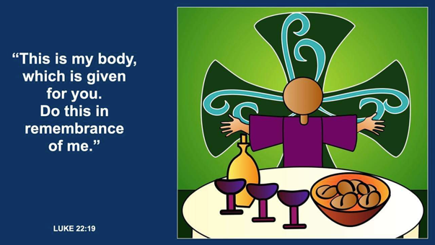

God be with you and also with you!
Lift up your hearts. We lift them up to God.
We thank the Risen Christ. We give thanks and praise.

God of wisdom and truth, we give thanks for joy in creation.
We celebrate your liberating love.
You gathered the diversity of Israel and spoke through prophets. Jesus gathered disciples and walked the way of the cross.
After suffering and dying, Jesus rose on the third day.

With witnesses from every age, we gather at your table, singing:
Holy, holy, holy Lord, God of power and might,
Heaven and earth are full of your glory.
Hosanna in the highest.
Blessed is the One who comes in the name of the Lord.
Hosanna in the highest.
Gracious God, in Jesus we see praying and fasting,
healing and hospitality, teaching and guiding.
We see the extent of your love for us.
We see the depths of our rejection of you.

Send your Spirit upon those gathered here.
May this community be an outpouring of your love and healing. Send that same Spirit upon this bread and wine,
May these gifts become our nourishment in the life of Christ.

Jesus gave thanks to God, broke the bread, gave it to his disciples, saying,
"Take eat: This is my Body, given for you. Remember me".

After supper Jesus took the winecup, gave thanks,
shared the cup with his disciples, saying,
"Drink this, all of you: The blood of the new Covenant,
given for you and many for the forgiveness of sins.
Remember me"

Great is the mystery of faith.
Christ has died. Christ is risen. Christ will come again.
We break this bread to share in the body of Christ.
BLESSING
Live simply, lightly, gently. Live in obedience and love.
And the blessing of God – Creator, Redeemer and Comforter, be with you now and forever. Amen.

