English Class Information

At our classes you can practise speaking English in an enjoyable and relaxed way. We will help you to improve your English speaking, and to learn more about life in Australia. You will make new friends as you join us in English classes. All the teachers and helpers are volunteers.

Class Times:
MONDAY MORNINGS: 9.30am to 11am
TUESDAY EVENINGS: 7.30pm to 9pm
FRIDAY MORNING CLASS: 10am to 11.30am
Classes are not held during the school holidays.
When church premises are closed due to pandemic, online classes are held.

We have separate graded classes.

Extra – Bible stories in Easy English
You are welcome to join an extra class to hear and talk about the Bible, and to learn more English.

MONDAYS 11.15am to 12.15pm.

Fee:
There is no fee. At the beginning of each term you are invited to give $5 to help cover the costs of running the English classes. We will understand if you cannot give $5 because of financial hardship.

How to join our English classes:
You are welcome to join our classes.
The first time, please come 15 minutes early and bring a paper with your name, phone number and address. You will be asked to answer some questions to help us find the best class for you.

在我们的课堂上，您可以以轻松愉快的方式练习英语。我们帮助您提高您的口语水平，并了解更多关于澳大利亚的文化生活。
当您参加英语课程时，您也会認識新朋友。
所有英语课程的老师和助手都是志愿者。
上课时间：
星期一上午 9:30 至上午 11:00
星期二晚上 7:30 至 晚上 9:00
星期五上午10:00 至11:30
( 学校假期暫停。)
當教堂因疫情而關閉時，將舉行在線課程。
我们按不同程度分班。
另外 - 简易英语圣经故事班
欢迎您参加额外的课程，听取和谈论圣经，并学习更多的英语。
星期一上午 11:15 至中午 12:15
学费
没有任何学费。在每学期开始时，請您交5澳元的材料费用。如有困难者可免繳。
報名手續
首次報名者请提前15分钟到来，請带上写着您的英文名字，电话号码和英文地址的便條。您需要做一個簡單英文評估之後,為你安排一個合适的班級。

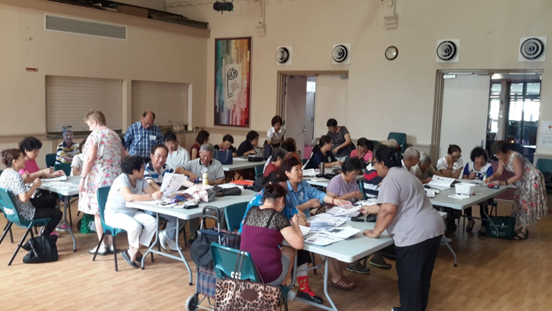

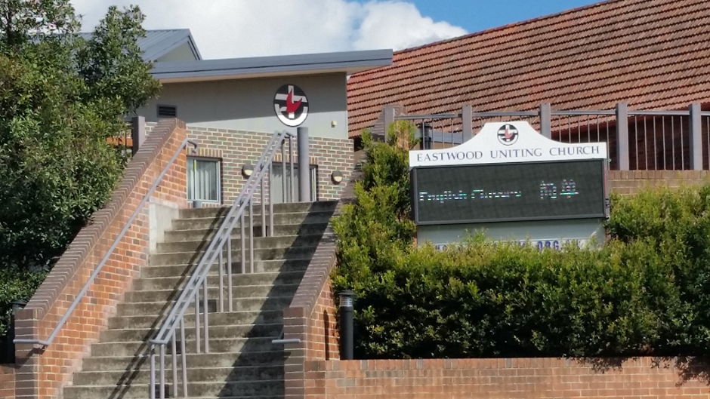

伊士活联合教會
英文班

電話 9858 5732 ( 英語 )
靠近火車站和圖書館

English Classes
at Eastwood Uniting Church

14-16 Lakeside Road Eastwood 2122

Corner Lakeside and Hillview Road
Eastwood. Phone: 9858 5732

Close to transport and shopping centre

