FIVE MEANS OF GRACE

Welcome to our Small Group studies – each session outline is structured for 55 minutes, but we plan to be online from 8pm and conclude no later than 9.15pm.
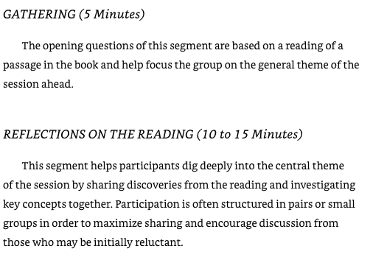

The links to the video is on our webpage AND listed in each study. Please open the link to check before you share screen.
When you go to zoom to share screen, check that the boxes are ticked for video optimization and sound sharing from your computer. The video should be heard by others when you are muted.
When the video is playing, keep an eye on the chat – that way anyone who has a comment or question can do so without interrupting the video.
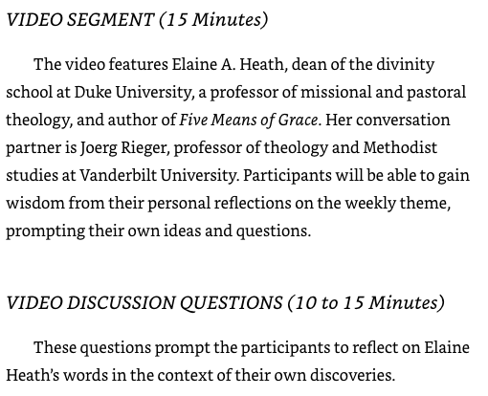
NOTE – If there are more than 7 people, slit into conversation groups by having breakout rooms. Put on a timer.

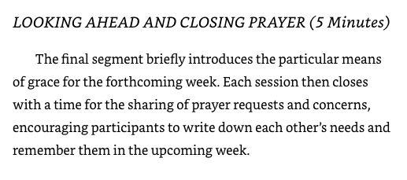

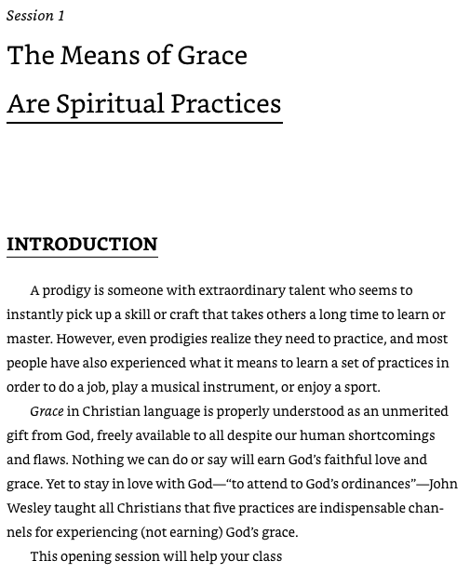
1.​explore the concept of grace and why it is a foundational topic for spiritual growth;
2.​offer initial impressions of the five means of grace as a baseline for understanding; and
3.​commit together to create an environment of support, prayer, and trust.
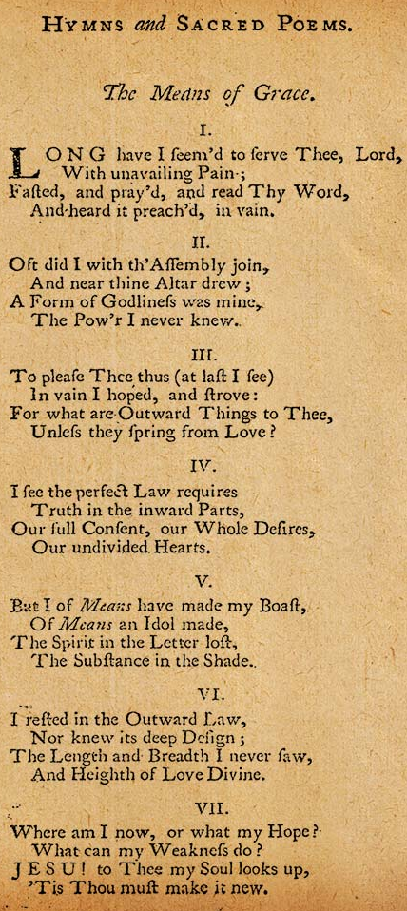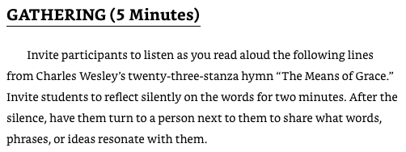
1.
Long have I seem’d to serve Thee, Lord,
With unavailing pain;
Fasted, and pray’d and read Thy word,
And heard it preach’d, in vain.
2.
Oft did I with th’ assembly join,
And near Thine altar drew;
A form of godliness was mine,
The power I never knew.
3.
To please Thee thus (at last I see)
In vain I hoped and strove:
For what are outward things to Thee,
Unless they spring from love?
Full text - https://scriptoriumdaily.com/charles-wesley-on-means-of-grace/

