TO: uniting.stamps@gmail.com or
PO Box 5078. South Turramurra. 2074
by July 31, 2021.

Stamp Committee Grant Application

Congregation: Eastwood Uniting Church
Sydney Central Coast Presbytery

Church Office (9am to 3pm, Tues-Fri) secretary@euc.org.au
Church postal address: P.O. Box 324, EASTWOOD, NSW 2122
Street address: 14-16 Lakeside Road, EASTWOOD, NSW
Our Bank Account details are as follows:
Eastwood UC Account BSB: 634 634 Account #: 100020668

Project: English-Chinese language project
Project Co-ordinator: Rev Dr Amelia Koh-Butler

Background
Eastwood UC is committed to trying to grow the Chinese community outreach and support the fledgling new plant of Mandarin-speaking service. We are conscious that we now also have a number of Cantonese-speakers and could also look to starting a Cantonese service or Bible study. We are stretching our current resources to capacity.

Apart from Rev Tennyson Chan working half-time, we now also have Wynne Wen Chen assisting Rev Amelia Koh-Butler. She is Cantonese speaking with some Mandarin and is doing 5 hours per week as Amelia’s interpreter/translater. She has a BMin from Christ College. We need to get some equipment to assist Wynne to do the work of translating resources, both for Eastwood and for the wider church.

Outreach/Community Benefits
Wynne has only been working with us for a matter of weeks. In the first 4 weeks, we have identified 2 new volunteers to assist in the work and we have started translating aspects of the new website, which is now regularly accessed by several other congregations who have Chinese members or Chinese outreach.
Here is a sample of how the English and Chinese versions of the website now look:

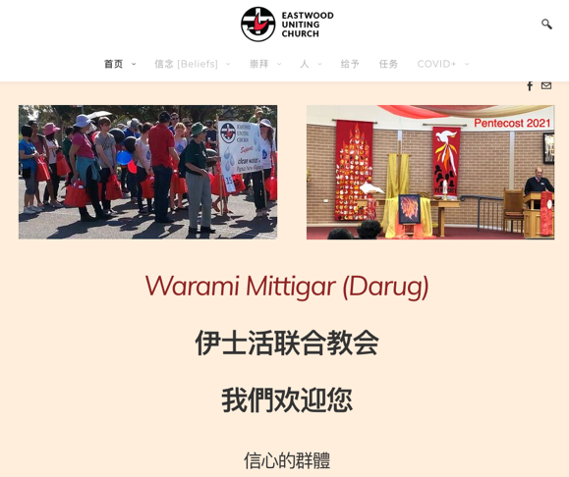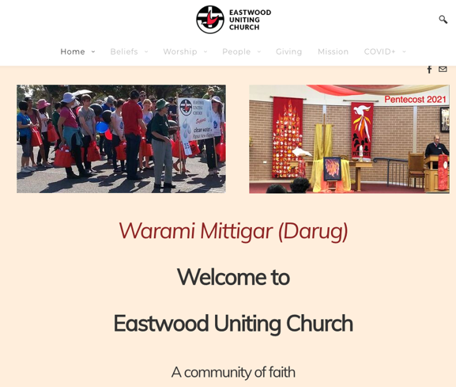

Involvement of Volunteers
The purchase of a tablet, microphone and earbuds will enable Wynne to coordinate the new volunteers and record resources for upload to the site.
We have 7 volunteers in the Chinese language leadership team (2 are new since this section of the project began) and we have 9 English-speaking volunteers who assist with English language classes.

Requested Resources and Costings
We are looking to purchase a tablet/notebook, earbuds with microphone and mouse/stylus.
We have costed this on Kogan and Officeworks at $1180-$$1300. (This is variable dependant on current stocks available in the SPECIALS.) The total cost is likely to be $1100-$1200 and the balance beyond $1000 from the grant will come from fundraised donations.

Eastwood UC continues to be an active supporter of Stamp Committee and we are grateful for the work you do.

Many thanks

Rev Dr Amelia Koh-Butler,
On behalf of Eastwood UC

