Office use only
Date received by ACOMP exec:
Click or tap to enter a date.

Community Catalyst Minister

Eastwood Uniting Church

A Placement in the

Sydney Central Coast Presbytery
Profile approved by PRC: Click or tap to enter a date.

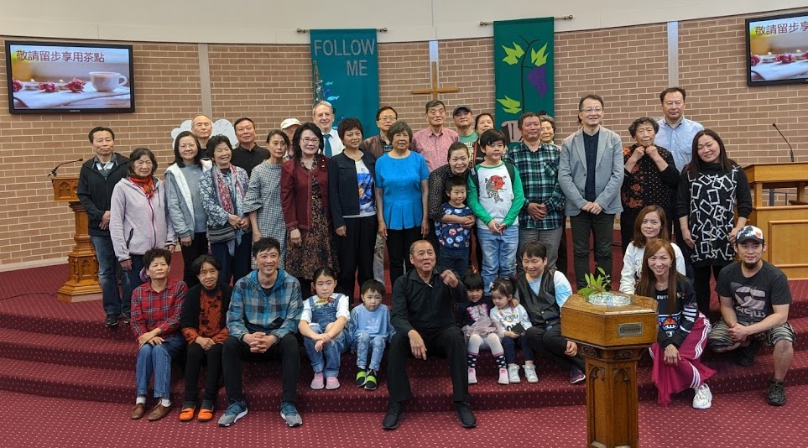

Purpose
The purpose of this profile is to:
- Provide an opportunity for congregations to communicate with a prospective minister their sense of identity, context, missional directions and goals, and describe the leadership envisioned and sought by the church and presbytery.
- Inspire interest in the congregation from prospective ministers, by providing information to enable a minister to discern if this is a community in which their gifts can be expressed and used effectively.

Presbytery Role
It is Presbytery’s responsibility to facilitate the completion of the profile. The Presbytery has the responsibility to carry out a “special consultation or mission study” (Reg. 2.6.6(a) and 3.1.4(a)) when a congregation is seeking a new placement. This ‘mission study’ may build upon a Life and Witness Consultation carried out within the last two years, or called by Presbytery in light of the impending ministry vacancy. The mission study and the task of completing the Profile should inform each other. The Presbytery also has responsibility for helping the Church Council and Joint Nominating Committee (JNC) complete the profile. One of the roles of the Joint Nominating Committee chair is to help identify the distinctive gifting and calling of the congregation.

Sources
Information about your town or region can be gained from:
- The Australian Bureau of Statistics (https://www.abs.gov.au/)
- Local Government Community Profiles obtained from your local Council Office
- Local Information
- NCLS Community Profile (https://www.ncls.org.au/)

Presentation
JNCs have permission to be creative in the way they present information in this profile, including linking parts of the profile to online resources such as websites and social media presence and resources. Need help with this? Here’s a simple instruction: https://www.lifewire.com/using-hyperlinks-in-a-word-document-3539981, or Google ‘How to insert hyperlinks in Word’ for more ideas.

Table of Contents
Placement Details 2
Our Story 4
Congregation Identity 5
Membership 5
Worship 5
Groups 5
Key Events: Witness and Service 6
Social, Cultural and Linguistic Diversity 6
Social Context of the local community 7
Community Engagement 7
Partnership 8
Future Direction 9
The Direction and Goals of the Placement 9
Leadership in the Placement 10
Ministry responsibilities in this Placement 11
Presbytery 12
Pastoral Relations Committee approval 13
Joint Nominating Committee 13

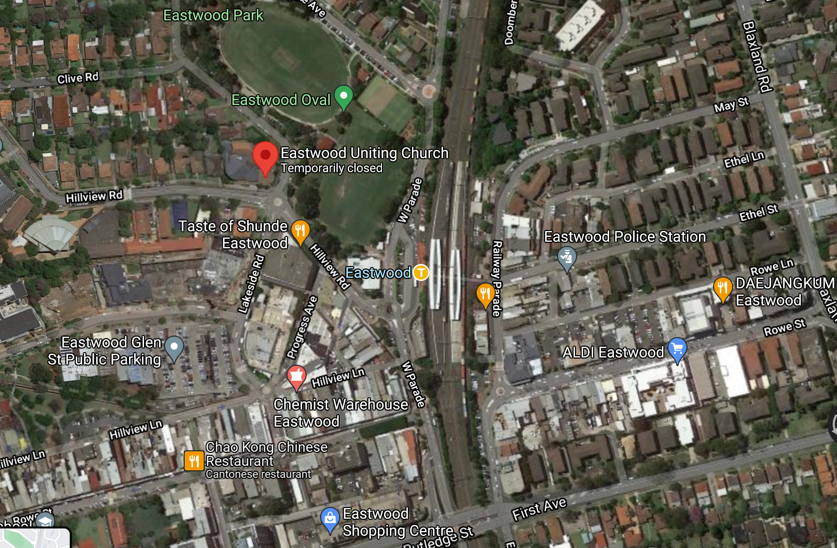
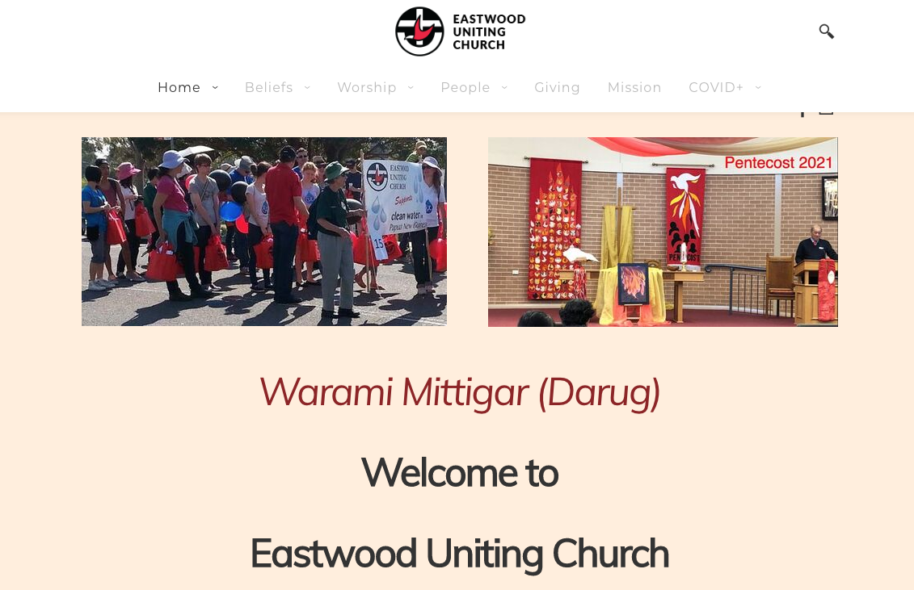
Placement Details
Name of Placement | Community Catalyst Minister
Placement physical  Address(es) 1 | Eastwood Uniting Church
Address 2 | 14-16 Lakeside Road
Address 3 | EASTWOOD
Office location | As above
Residence location or options
Ministry leadership being sought  (please tick as many as you wish) | Specific ministry role: | Community Catalyst Minister, part of the Mission Team at Eastwood Uniting Church
 | Minister of the Word ☒ | Deacon ☒ |  | Ministry of Pastor ☒
Specific details | Additional placement ☒ Replacement placement ☐
 | Previous incumbent: |  | Previously, Eastwood has had a similar role, filled by a Minister of another denomination, working under an employment contract
 | Full Time ☐ Part Time ☒ |  | 50% negotiable:
 | Start Date |  | asap
Permission sought to advertise | Yes ☒ If not filled by ACOMP
Reason (Presbytery) | Placement requires knowledge of Asian culture and Chinese language.  If we cannot readily identify and call a candidate, we may need to look into Chinese-speaking networks beyond the easy reach of ACOMP.
Is Priority Placement recommended by Presbytery? | Yes ☒ No ☐
Reason (Presbytery) | Placement requires knowledge of Asian culture and Chinese language.
Contact Person | Usually Convenor of JNC  Secretary at EUC – mark “Confidential enquiry”
Email address | secretary@euc.org.au
Website | https://www.eastwooduca.org/
Social Media | https://www.facebook.com/EastwoodUnitingChurch  weChat
Google Map link | https://www.google.com.au/maps/place/Eastwood+Uniting+Church/@-33.7893187,151.0781174,17z/data=!4m12!1m6!3m5!1s0x6b12a43a3c972211:0xedbeaecc56d1b4da!2sEastwood+Uniting+Church!8m2!3d-33.7892354!4d151.0802926!3m4!1s0x6b12a43a3c972211:0xedbeaecc56d1b4da!8m2!3d-33.7892354!4d151.0802926

Our Story

Eastwood Uniting Church has a mission to “witness to the Gospel, spreading the Good News of Jesus Christ in word and action”. It seeks to connect with its diverse community through active discipleship.
We seek an energetic and collaborative community minister, to focus on mission and ministry, particularly with Asian populations reached from the Eastwood district. The evangelistic focus will be beyond the church property in Eastwood, towards the families and students from many nations attracted to this district. Some have heard of Jesus, but for many the Christian message is new. Our challenge is to look past current understandings of Christian community, and to grow a Christian community where all people are welcome, and can flourish, including Asian-Australians and temporary residents. We are also mindful that many Chinese and Koreans hold ordained ministers in a position of esteem and respect not always afforded to lay workers. It has been important for us that our current Community Resource Worker has been recognised in the wider community as an Ordained Minister.
The Minister will work with and within our Mission and Ministry Team to enable us to build on changes already made. We seek to develop Christian community that is diverse and inclusive, relevant, and appropriate for the 21st century. Given that most Chinese congregations are independent and isolated from the rest of the Christian Church, we need a person grounded in an inclusive theology, who is prepared to go beyond Chinese normative behaviours and understandings to work across boundaries. An innovative Minister will help us to develop and implement strategies to engage with bilingual people who often speak Mandarin, Cantonese or another Asian language at home.
We collaborate with other Uniting Church agencies in our endeavours, and these partnerships will continue. We will be working in partnership with all Synod councils, Sydney Central Coast Presbytery, and other congregations in the City of Ryde Zone. Uniting Mission and Education is a key partner in our work with the Mandarin-speaking community. We are partners with Epping Uniting Church and tertiary ministry in outreach at Macquarie University. Fresh approaches are sought to build a community that integrates international students from Macquarie University, young families, residents, and people who come to Eastwood to enjoy its services. Our church site is well located to operate as a hub for outreach to these people and we are partners with Christian Community Aid.
Alongside, there is a continuing ministry with the existing church congregation, including a Mandarin-speaking worship group and some Cantonese-speakers. We are open to diversity in worship, from very traditional to intergenerational activities. With a number of new believers, ‘in-language’ teaching will be essential for our community to flourish.
We publicly express that we are an inclusive community (God loves all people), and particularly that we welcome refugees and people who identify as LGBTQIA. We choose to use inclusive language. We appreciate that this is a barrier to people whose culture or traditions do not accept this position. This sets us apart from some Christian denominations in Eastwood. We see this as a strength rather than an obstacle.

The Community Catalyst Minister will:
- Assess the needs of people within the local community based on information gathered from various sources about the nature of the community and the needs of different groups.
- Develop and evaluate different approaches to building meaningful relationships between church and the local community. Assess the merits of these approaches relative to the characteristics of the various demographic groups so preferred approaches can be identified and pursued.
- Participate in documenting the systems, policies, and procedures developed to enable efficient implementation of the most effective services, programs, activities, and events. Collaborate with Presbytery and Synod representatives to ensure the output satisfies their requirements for the material to have broader application.
- Assist Eastwood congregation members to grow their connection with new residents beyond the point-of-contacts relationships with English-language-learning groups at Eastwood.
- Share with the other Minister and leaders at Eastwood to:
- develop understandings and behaviours within the congregations to assist them to be open and hospitable;
- grow relationships with people not currently connected with the Christian church, particularly noting the large proportion of the local community with Asian heritage; and
- assist the congregations to connect with tertiary students
- Connect with and lead Eastwood Chinese-speaking worship (usually twice per month). As appropriate, conduct or assist with Pastoral Services principally weddings, baptisms, and funerals.

Congregation Identity
What sense of church do the people share? What sense of mission do they share?
You could link to (or attach) your recent congregational Annual Report or Life and Witness (L&W) Report.

Membership
Number of Confirmed Members | 179
Numbers who attend worship in total per week | 110 (hard to say during COVID)  We have a lot of older members who have been unable to attend live or online worship since the outbreak of the Pandemic. We keep in contact with them via mail, phone and delivery.
Number of members receiving specific pastoral care | 280 (this represent a significant increase through community ministry during 2019-2021)
Have there been any significant changes in membership in the last 2 years? Describe the change.
Much of this information is ‘best-guess’ during the COVID19 situation that has developed in 2020-2021. It represents our best-educated guesses at July 2021.
A worship service in Mandarin language at 2.00pm on Sunday commenced in June 2018. It was initiated after some Chinese people who attended Wesley Mission and other churches sought space at EUC for a weekly Bible study group. From the initial 24 people who transferred their membership the average attendance increased to 30 – 35 and, during COVID times, has settled back to around 25 people. We note that COVID has necessitated some of our community to return to countries of origin and others have struggled with life as an Asian-Australian during the pandemic. Racism in our community has increased significantly, leading to added stresses on our members and increasing the need for targeted support.
Most of the core leadership team of the 2.00pm service is comprised of people who live outside the Eastwood area, but some newcomers live in the Ryde-Eastwood district. There continue to be regular people coming to faith, with a recent adult baptism held just before lockdown. The 2.00pm worship group hold a weekly prayer meeting and a Bible study meeting twice a month.
The responses of the Eastwood Uniting Church Congregation to the National Church Life Survey in 2016 provide an insight into changes at Eastwood from 2011 to 2016. More recently a survey was conducted as part of a Life and Witness consultation. The following summary explains changes since 2016 and compares Eastwood with the average for all Uniting Churches in NSW (in brackets below).
Eastwood Uniting Church attenders most value:
- Wider community care / social justice emphasis (av.=48%)
Openness to social / cultural diversity (av. =37%)
Sermons, preaching or Bible teaching (av. =27%)
Attenders would like priority given to:
- Worship services that are nurturing 42% (av. = 36%)
Building a stronger sense of community in EUC 32% (av. = 29%)
Ministry to children and youth 32% (av. = 23%)
- 43% of attenders have a strong and growing sense of belonging (av. = 48%).
- 11% of attenders regularly give 10% or more of their income to EUC (av. = 17%).
- 74% of attenders are aware of, and committed to, the vision, goals, and directions of EUC (av. 62%)
- 24% of attenders are confident EUC can achieve its vision, goals, and directions (av. = 29%).
- attenders are mostly aware of the EUC vision and direction, but not confident the vision and goals will be achieved.
- 86% of attenders agree EUC is always ready to try new things (av. = 72%).
Approximate number in each age range (estimated): |  | 0 – 29 | 30 – 59 | 60 – 79 | 80+
 |  | 12 | 40 | 50 | 50

Worship

Worship services or worship-related gatherings each week
Style of Service | Time | Av. Attendance
Informal, mostly lay-led | 8am | 12-25
Inclusive (with Sunday School)  Once-a-month – ‘something different’ services | 9.30am | Online 25 households  Live – approx. 50
Evangelical Chinese service | 2pm | 24-35 (variable)
Note: the 9.30am service is the most multicultural because people from a variety of Asian and European backgrounds attend. To assist some bilingual people portions of the service are led and displayed on screens in multiple languages.

Over the last two years, how many:
Baptisms | 18 (mostly through the 2pm)
Weddings | 2
Funerals | 10
Other pastoral services | No record

Groups

What regular groups meet in your congregation?
Note – there are a significant number of specifically English-speaking groups – Bible Studies, Sunday School, Fellowships, etc… Below we are listing those specifically connected to this Placement and which would draw some focus for the Minister in Placement
Group | Time of week / frequency | Attendance
English language classes  (depends on time of year and lockdown progress) | weekly | 12-50
Easy English Bible group | Weekly during term-time | 8
Chinese-language Bible Studies | Fortnightly and seasonal | 14
Chinese-language Leader development | Fortnightly | 8
Chinese-speaking prayer group  Chinese Music Group | Weekly  Weekly during term | 12  25-30

Key Events: Witness and Service

What does witness and service look like in your Congregation?
Linked to the English classes, opportunities are offered in various forms for those interested to engage in Christian bible class.
In 2016 EUC established the position of Community Resource Worker. The objectives of this initiative continue and are incorporated into this Placement: to connect Chinese people to faith, to identify and respond to the needs of the Chinese speaking community in Eastwood, and to work with EUC Ministry team and members of the Congregation to further develop opportunities for the local Chinese community to participate in faith sharing and worship at Eastwood Uniting Church.
EUC has partnerships and representatives on the boards of Christian Community Aid (CCA), UnitingNetwork and the Eastwood Uniting Church Musical Society. Their activities bring to the site many people from the local community and district.
The Church facilities are heavily used by community groups, both for-profit and not-for-profit.
EUC takes part in annual local community activities (see below). EUC supports Synod and Assembly activities such as affordable housing advocacy, Palm Sunday march, advocacy for refugees, Climate Action rallies and UnitingWorld.
EUC holds Community Coffee mornings (advertised in Chinese) at a local café on a fortnightly basis. These are attended by at least 14 Chinese-speaking people ( not previously been connected with church). Chinese congregation members do some street evangelism – handing out resources when COVID restrictions allow.
We are now working on building a website with full Chinese and Korean integration of resources. This is an ambitious project. Initial work can be viewed on our new website. www.eastwoodUCA.org

What are regular key events and occasions in the life of the congregation?
What is their significance to the congregation?
- Granny Smith Festival – an annual October local festival
- Lunar New Year (January/ February) - with concerts and services in the church.
- Thanksgiving and Remembrance events
- Lent Event
- Holy Week (including Maundy Thursday) – this is new for Chinese Christians!
- Christmas Bowl
- Blessing of the backpacks (beginning of the school year)
- UCA anniversary
- Heritage Sunday (celebrating aspects of Eastwood UC and its former congregations)
- UCA Assembly Iftar Dinner

Social, Cultural and Linguistic Diversity
What ethnic and language groups are represented in the congregation? proportion of the congregation?
English and Chinese (18%) are the main language groups. People from several ethnic and language groups are part of the congregation, including German, Dutch, Italian and Czech.
The 2.00 pm worship service is entirely Mandarin language, although many attenders are bilingual. Other worship services are primarily English speaking with visual information in Chinese and Korean
We have recently appointed a new Team member in our office who is Sri Lankan and brings additional language skills to our team.
Does the congregation have a particular ministry or openness to certain people that shapes your identity?
The congregation is deliberately inclusive and is working at becoming affirming for LGBTIQ+ members.
Mission with People of Chinese Ancestry
A Chinese-speaking Resource worker was appointed in September 2016. Connections, in Cantonese or Mandarin, have included:
- ‘Good morning Eastwood’ (morning teas in the school holidays held in the early years of the project)
- Happy Friends Club (Tuesday afternoons, attendances 10 to 50, depending on speakers)
- Participation in EUC 9.30am worship services recognising Chinese festivals, mid-week Christmas services in Chinese language
- Bus excursions (45 people each trip).
- Assisting with EUC’s ‘English & Bible’ classes each Tuesday morning.
- Engaging in conversations at ‘Chit Chat Corner’ each Tuesday morning, in conjunction with CCA’s Community Learning Program.
- Active involvement in the BBQ outreach at both Marsfield and Eastwood.
- Commencing the EUC 2.00pm Sunday Mandarin worship service.
- A monthly Sunday ‘fun day’ after the 2.00pm service.
- A weekly prayer meeting and a Bible study meeting twice a month in Mandarin.
The ‘Chinese community’ is not homogenous. Chinese people, or their parents, may have come from several countries. Some are citizens, some have been permanent residents for decades, but others are recent arrivals. Some are Christians, some have another religion, and many have no religion. Many students at Macquarie and Western Sydney Universities live in Eastwood. There are now several generations within this community with different needs, expectations, aspirations, and goals. Main languages are Mandarin and Cantonese, but other Chinese languages are evident. English is the common language for most of the Chinese community. This issue continues to be complex due to the fluid situation of overseas students and migration into Australia. (e.g. Our recently appointed Minister of the Word is a 2nd Gen half-Chinese person with no Chinese language skills.)
Are there cultural practices that contribute to the life of your community?
We work with Ryde Council and CCA to celebrate a number of cultural events.
We are now regularly learning a few words in Darug, Korean and Chinese languages to greet people.
What relationships does the congregation presently have with Aboriginal people? Is the congregation involved in any covenanting activities?
Eastwood UC has a strong commitment to Covenanting. Our multilingual NAIDOC service featured on the Assembly Covenanting portal and we hosted Nathan Tyson as our guest speaker, also helping him to develop sharable resources for other congregations.
We are learning some words in Darug.
We have had special services for Sorry Day and publish resources about Acknowledgement of Country. Several of our members are active in practical Covenanting activities ‘on country’. EUC recently priorotised the distribution from Sales proceeds to UAICC as part of our ongoing relationship and responsibility to support Congress.

Social Context of the local community
General:
Eastwood is suburban; multicultural, with most people having European, Chinese, or Korean heritage; mostly middle-class residents; some more vulnerable students and older relatives of working migrants; a transient student population; many are well educated. However, there are some boarding houses and a significant number of Aged Care and Rehab facilities. The district has strong education and health care; a lively retail/commercial centre; many restaurants and cafes; major employers at Macquarie Park particularly technology companies.
Rationale for Chinese focus:
Eastwood’s population is around 14,443 (2016 census), but the shopping centre draws people from an area of over 100,000 people. This includes an area previously served by Denistone East Uniting Church. It is appropriate that funds from the sale of Denistone East be applied to future mission activities in this area. Many Chinese and Koreans travel from out of area. Some relevant conclusions are:
- The recent period of demographic transition has continued with a declining number of people of European ancestry. The proportion of the population with European ancestry has fallen to 30%. It is forecast that this trend will continue over the next decade.
- Now 21,000 people (70%) were born in Asia or have Asian ancestry.
- Of the 17,000 people born overseas, 14,000 were born in China.

- There are 6,000 people (20%) who identify as having ancestry from Asian countries other than China, such as South Korea, Philippines, India, Vietnam, and Indonesia.
- People who identify as having Chinese ancestry were born in numerous countries and may not speak a Chinese language. They may have migrated from countries such as Malaysia and Singapore, or been born in Australia.
- English is the common language for the people from these countries as 85% of the population speak English well or very well.
- A group of 2,000 overseas born people are Chinese speakers who do not speak English well or very well. It is forecast that this number will decline over the next decade.
- There is a large group of young adults in the 18 to 29 years age groups (7,500 people).
- The 4,500 people who attend university all speak English, majority aged 18 to 29.
- Half of the 3,000 bilingual Chinese speaking (Mandarin and Cantonese) university students live in ‘group households.’
- The largest cohort of Chinese speakers is bilingual households (9000 people). Parents in these households may have been born in an Asian country (eg. China, Taiwan, Singapore etc.), or Australia, and speak English and a Chinese language. Half of the households speak a Chinese language at home.
A large and growing proportion of households are ‘couple with young children’ (7500 people). The children are primary school age or younger, and mostly born in Australia. The parents are bilingual Chinese speakers but the children mostly speak English once they attend school.
In Eastwood now the number of people with ‘no religion’ is equal to the number of people who identify as Christian. The number of people who identify as Buddhist is the same as the number of Anglicans. In the 2011 – 2016 period the number of Uniting Church attenders declined by 30% to 600 people. It is expected that the decline will have continued.
Half of the people in the Eastwood district, 15,000 people, are not Christians and speak English well or very well. If Eastwood Uniting Church reached 2% of this cohort it would represent 300 people.
COVID-19 and the changes to security laws in Hong Kong have the potential to influence migration patterns. Students from Hong Kong are more likely to choose to stay in Australia after graduating from Macquarie University. More Hong Kong residents may decide to come to Australia.

Please find your community using the ABS Quickstats page and copy & paste a link(s) to YOUR community in this grey box:
Prospective Ministers are encouraged to click the link and learn about this community
https://quickstats.censusdata.abs.gov.au/census_services/getproduct/census/2016/quickstat/SSC11369?opendocument

What makes your wider community a good place to live?
- Proximity to diverse options for education and health
- Transport hub
- Restaurants and eating establishments in the commercial centre.
- Shops and offices that focus on serving specialist needs (eg. providores, food stores, travel etc)
- Community facilities (library, parks, ovals).
- Diversity of housing including low-medium density, apartments, boarding houses, seniors housing.

What are the points of stress and pain in the wider community?
- Long term residents have expressed a sense of loss for what used to be their ‘village.’
- As Eastwood draws people from a wide area there is a sense of the locals competing with outsiders for services and space.
- Continuing construction of houses and villa houses as part of the regeneration of the area contributes to a feeling of perpetual change.
- Apartment buildings and shop top housing in Eastwood have changed the street landscape.
- The busy atmosphere in Eastwood centre with the related traffic conflicts, and pedestrian congestion, creates stress for some people.

How closely does your congregation reflect the demographics of your local area?
- A high percentage of the congregation does not live in postcode 2122. Some attenders have always lived in nearby suburbs but others have moved away from Eastwood to new accommodation as they have grown older. The congregation reflects the long-time residents more than the present population.
- This reflects the challenge now faced by the congregation. Deliberate action is needed to address this imbalance.

Community Engagement

List three ways in which you most closely connect with, serve or partner with people in your wider community?
Christian Community Aid (CCA) uses the Church buildings Tuesdays-Thursdays. Tuesdays and Wednesdays are activities specifically for Chinese-speaking people. The Congregation is represented on the CCA Board. Members of the Congregation bring food on Sundays to contribute to CCA’s food bank.
English classes are delivered by EUC on Monday mornings, Tuesday evenings, and Friday mornings. These classes bring together non-native English speakers and volunteer teachers from the wider community.
Prior to COVID Community Bar-b-ques in Marsfield and Eastwood and participation in local festivals created relationships in a safe environment.
During this period, we are trying to build a stronger online presence with the provision of multilingual resources and support structures. See www.EastwoodUCA.org

If you rent or share church property, how do you engage with your tenants?
- The rationalisation of properties over the past decade was undertaken to create a central ‘hub’. The facilities are commercially central and provide for a wide variety of activities.
- Christian Community Aid uses the property for a variety of programs that cannot be accommodated at its offices. This space is provided at a very heavily subsidised ‘rent.’ There are good communication and relationships with Christian Community Aid.
- Eastwood Uniting Church Musical Society (EUCMS) - The Congregation has appointed a member to be the liaison person with EUCMS. The financial contribution EUCMS makes is heavily subsidised by the Congregation.
- There are very good relationships with all users, including Kumon, Dance groups, Little Kickers etc., especially with groups that use the property during office hours.

Partnership

Who are you collaborating with in mission at the moment? Who do you plan to collaborate with in future?

Include neighbouring congregations, including Uniting Church and other denominations, key individuals, groups or institutions such as Uniting Care agencies, schools, businesses, community groups.
- Christian Community Aid.
- Macquarie University – working with Epping Uniting Church and the University chaplains through the Tertiary Reference Committee. It is intended that this collaboration will increase.
- Uniting Mission and Education has contributed to long-term continuing discussions about pursuing its desire to create a placement for a Mandarin-speaking minister based at Eastwood.
- NSW Synod – Eastwood UC’s Mission Plan is used as a ‘model’ for congregations
- Nearby congregations in the City of Ryde zone within Sydney Central Coast Presbytery.
- Lenten studies with St Kevin’s Roman Catholic Church and relationship with the Womens Prayer group at St Kevin’s.
- Eastwood Public School and Denistone East Public School for Special Religious Education.
- United Theological College for field placements.

Future Direction

The Direction and Goals of the Placement
The Eastwood Community Catalyst Minister will:
- identify opportunities and develop initiatives to engage with groups of people currently not within the church community.
- ministry will extend current relationships and intentionally build relationships with new groups.
- provide input into documenting how services, activities, and events have been implemented.
The 2018 – 2022 Mission Plan adopted by the Congregation on 11 March 2018 has been subject to the consultation process required by the Synod Sales Proceeds Policy, and was endorsed by Presbytery on 10 August 2018. It is an ambitious plan and states, “The utilisation of proceeds from the sale of 17 Acacia Street, Denistone, is necessary to facilitate this Mission Plan.”
“The highest priority in mission must be to the demographic with Asian heritage that now characterises the Eastwood centre and its surrounds. The initial goal is for Eastwood UC to have a strong missional connection with our Chinese-speaking community by 2020.” (August 2018)

The Mission Plan identified the Eastwood UC Ministry Team as:
People: We need a team of people with diverse skills that can provide a range of ministry and pastoral services. The people required for this team will be:
- A Minister of the Word who will be the leader of the ministry team. This is a full-time position.
- Office staff to provide 50 hours per week of administrative support for the ministry team and the congregation.
- A Catalyst Minister for 20 hours per week who can focus on outreach and connection with the local community of Chinese heritage.
The longer-term vision is for growing the team to include
- A mission worker who can focus on outreach to families with young children from multicultural backgrounds. (2nd priority).
- A mission worker who can focus on outreach to youth and young adults, particularly tertiary students from multicultural backgrounds. (3rd priority).

What progress has the congregation made toward these goals?
The appointment of a 2nd Gen Aussie-Chinese Minister (who is also an Accredited Youth Worker with experience in working with young people has assisted with the 2nd and 3rd priority areas).
This refocuses us on the need to address the connection with the Chinese and Korean communities better.
We now have a shorter-term Chinese language support project and a Korean student Minister.
The Sale of a property at Denistone allows us to proceed with the next stage if NREMA funds can be used for this position.
In our last profile, we noted the following:
“Uniting Mission and Education verbally requested in December 2019 that the congregation consider an amendment to the Mission Plan’s future options. Under this option the current Chinese-speaking Resource Worker position would be absorbed into a part time placement for an ordained minister. The placement would enable the existing Mandarin language service to be expanded, and for the needs of the people attending this service to be better served.
Eastwood Congregation are hoping we can use Sales proceeds to fund 50% of a Placement in the hope that the further building of a team can happen in collaboration with other sectors of the church. To this end, we have been in conversations with Epping UC and the Presbytery about possible collaborations.

What will be the next strategic steps toward achieving the vision?
During COVID it has been a miracle to be able to sustain a new community of Chinese.
We need to stabilise and build that group in order to support new leaders to develop and take up roles in the next steps… to engage with family and younger people ministries.
We need to further develop our online presence in Chinese language and build resources for evangelism and discipleship.

How has the congregation changed in the last five years?
If current trends continue, what is the outlook for the congregation’s health in the next five to ten years?
Five years ago there was no Chinese fellowship or worship group here. It is new and shiny. It also needs intentional support and stability. Having a half-time Placement with some regular preaching will be part of stabilising the community and enabling them to refocus on mission.

Are any major changes or developments anticipated in the placement in the next three to five years?
We expect a number of the newly baptised people to begin to take up service and leadership roles in mission and ministry. To that end, the Placement would come at a time when an experienced leader is needed to guide enthusiastic disciples.

Leadership in the Placement

Briefly describe the leadership structure of the placement, including the key committees
The congregation is responsible for key decisions. Congregational meetings are routinely held twice a year with the annual budget considered in June. If circumstances require an additional extraordinary meeting this is arranged.
The Congregation selects the Church Council. The Congregation Chair is a member of Church Council. Church Council generally meets monthly (as well as decision making by email and online meetings), and is comprised of 8 people, including the Minister. We have just moved to a structure of alternating Business Meetings and Mission Development meetings. There are 3 Chinese-speaking members. Most Church Council members have a specific role e.g. secretary, finance, education, caring. There are several “Umbrella Groups” that have delegated authority to oversee their areas of responsibility, to organise events, and report to Church Council. Examples of Umbrella Groups are: Pastoral Care, Education, Property, Communication.

What roles do members of the congregation have in leadership of worship, study, action and prayer groups, missional activities?
People in the congregation are provided with the opportunity to participate in worship, primarily through Bible readings, prayers of the people, sharing testimony, and assisting with sacraments. Members make up the Umbrella Groups and the Property Committee. Bible studies are led by members of the congregation.
People are empowered to ‘follow their passion,’ and there are connections beyond the local community with eco-theology groups, social justice action groups, and refugee support groups. Members of the congregation participate in public gatherings and marches together with the Moderator and representatives of other congregations.
Sydney Alliance has used the property for public gatherings. Within the life of the congregation people are supported to lead various groups e.g. Christian meditation, and trusted to take appropriate initiatives.

Are there significant gaps in key roles?
There are currently no gaps, but some people have too many responsibilities. With the aging of the congregation there is a declining number of people willing to share the workload.
Who looks after financial management and property? clear structures of accountability and oversight?
The Congregation appoints a treasurer (a qualified accountant) and an independent auditor.
Financial management is exercised by a combination of the treasurer and the office staff.
Uniting Resources manages the payroll.
Property matters, bookings and invoicing are managed by the Property Committee and Office Team.
Does the placement offer any administrative support? Is there a church office? Does it have up-to-date equipment? Is there secretarial or admin help based in the office? How many hours?
A modern, fully equipped Church office is open throughout the week and staffed Tuesday-Friday 9.00am - 3.30pm. Administrative support is provided by two staff who job-share 36 hours each week.

Community Catalyst Minister responsibilities
- Assess the needs of people within the local community based on information gathered from various sources about the nature of the community and the needs of different groups.
  - This involves strengthening relational networks of Eastwood UC and other Uniting Churches (particularly Epping), community groups, agencies, and community leaders.
  - Use this information to assist the congregations to develop their understanding of community relationships, community demographics, and community needs.
- Develop and evaluate different approaches to building meaningful relationships between church and the local community. Assess the merits of these approaches relative to the characteristics of the various demographic groups so preferred approaches can be identified and pursued.
- Participate in documenting the systems, policies, and procedures developed to enable efficient implementation of the most effective services, programs, activities, and events. Collaborate with Presbytery and Synod representatives to ensure the output satisfies their requirements for the material to have broader application.
- Assist Eastwood congregation members to grow their connection with new residents beyond the point-of-contacts relationships with English-language-learning groups at Eastwood.
- Share with the other Minister and leaders at Eastwood to:
- develop understandings and behaviours within the congregations to assist them to be open and hospitable;
- grow relationships with people not currently connected with the Christian church, particularly noting the large proportion of the local community with Asian heritage; and
- assist the congregations to connect with tertiary students
- Connect with and lead Eastwood Chinese-speaking worship (usually twice per month). As appropriate, conduct or assist with Pastoral Services principally weddings, baptisms, and funerals.

Is this ministry shared beyond this congregation?
This placement is for 3 years. It will need to be fully funded by Non-Real Estate Mission Activity grants.
[Epping UC is considering sharing in this role as a Joint Placement. Under such an arrangement, the nature of this placement is that the benefits of some outcomes will be shared equally rather than assisting only one congregation. Another goal is to assist Sydney Central Coast Presbytery and Synod in developing resources for mission that will be shared beyond Epping and Eastwood.
Although there are ongoing conversations about such possible collaborations with Epping UC and the expansion of this ministry into the future, Eastwood are needing to progress this with some urgency, having already invested significantly in developing a new ministry over the last three years. Without ongoing support at this point in time, we could lose the initial gains. Therefore, Eastwood are committing to the next three years of this mission initiative in faith that this is our best response to the presenting context for mission.
Current Staffing Arrangements: Please supply names and role designations of
- Current employed ministry agents/ministry team
- Other employed staff (office staff, musician, grounds, cleaner etc.)
- Unpaid active members of ministry team (honorary minister, voluntary lay ministry worker, lay preacher, lay presider, marriage celebrant)
Name | Designation and brief role description
Rev Dr Amelia Koh-Butler | Minister of the Word, Accredited Youth Worker and Team Leader
Michelle Loxton | Office Team - Admin
Nilu Thambamittu | Office Team - Admin
Wynne Wen Chen | Office Team – Chinese language project worker (temporary)
Is there a designated team leader? |  | Yes ☒ No ☐ | Amelia Koh-Butler

How are responsibilities allocated (e.g. by a particular person or consultatively)?
Consultatively with Team and liaison from Church Council.
Also participating in consulting about responsibilities is Rev Marion Gledhill (ret) who is a Minister-in-Association (Deacon)

Presbytery
This section requires significant detail. Please avoid one sentence answers.

Presbytery comments on the mission directions identified for the next 3-5 years?
Sydney Central Coast Presbytery has closely monitored Eastwood UC’s ministry with Chinese-speaking people, and its engagement in the chaplaincy to Macquarie University. The development of this position is supported by Presbytery on the basis of their mission planning and implementation. The placement of the current MOW incumbent was made with this overall direction in mind. While SCCP has long ministry experience with Korean and Indonesian (Asian) congregations, other congregations in Northern Sydney and elsewhere are also exploring ways to grow in ministry with Chinese speakers.
PRC is continuing to support EUC as this placement takes shape.

Presbytery perspective on this ministry’s life and future?
PRC would prefer to see a full-time placement with an open timeframe. This will depend in large part on the priorities of the Synod in releasing proceeds of sale for this role, and also on Epping and perhaps other congregations in their own mission planning.
The UC has very limited missional connection with Chinese background people and few ministry agents with the necessary language skills. This role is therefore ‘cutting edge’ in opening doors to Sydney’s largest migrant-ethnic population. Its success is not guaranteed but should be a high priority.
For which ministries does the Presbytery consider that the position is suitable?
Minister of the Word ☒ | Deacon ☒ | Ministry of Pastor ☒ | Note the observation on the preference for an ordained minister, above.
Is the Presbytery satisfied that adequate and appropriate accommodation will be available? |  |  | Yes ☐ No ☐

If not, what is being arranged?
Housing will need to be funded from the NREMA allocation.
Adequate financial support for the placement and other expenses will be available? |  |  | Yes ☐ No ☐

Source of funds (Congregation, grants, Presbytery, other)
Requires NREMA funds, possible from the current Sales Proceeds just become available from the sale of a property at Denistone.
Financial support documents to be attached: |  | ☐ Profit and Loss Sheet  ☐ Balance Sheet  ☐ Budget

Pastoral Relations Committee approval
Date of Pastoral Relations Committee approval | Click or tap to enter a date.
Date on which form is forwarded to Synod | Click or tap to enter a date.

Signature |  | Date
 |  |  | Click or tap to enter a date.
 | Chairperson/Secretary of PRC

Checklist for PRC Convener
☐ | The Profiles are complete and have been approved by PRC
☐ | Adequate Manse Plans are attached or description of alternative housing has been approved
☐ | Preliminary Terms of Placement have been completed
☐ | Financial details including Profit and Loss sheet, balance sheet and budget are attached and have been reviewed by Presbytery to ensure confidence that the Placement can be sustained
☐ | Copy of the draft advertisement if position is to be advertised. Advertising Template link.
☐ | Presbytery section is complete

Joint Nominating Committee
Convenor
Phone
Address
Email

Checklist for JNC Convener
☐ | Profile completed and accepted by Church Council
☐ | Manse OR alternative housing arrangements
☐ | Financial records copied and attached
☐ | Congregational members of JNC
☐ | Presbytery-appointed members of JNC

Step 1: Congregation
Please send this to your Presbytery for comments.

Step 2: Presbytery
Please email the completed and signed profile to acomp@nswact.uca.org.au

Click here or here: https://quickstats.censusdata.abs.gov.au/census_services/getproduct/census/2016/quickstat/1 then enter some location information in the QuickStats Search bar where it says, “Find a Location”. You can enter your postcode or a more generic phrase like ‘Northern Beaches’ or ‘Southern Highlands’. Click on the most likely place as it appears.

