A-J Study – Week 6
Session 6. GETHSEMANE
RISKING TEMPTATION
Session Goals
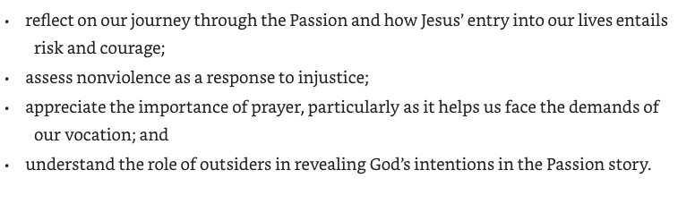

Opening Activity – Report Back on the Neighbour Commitment

- How did people go with connecting with their neighbours?

Consider when you had to take a risk and be courageous
- What was the occasion
- What fears did you have to overcome in order to act?
- Who helped you face your fears?
- If you prayed at that time, what did you say to God?
A volunteer or two may share…

In our discussion session, we are going to consider Jesus praying at Gethsemane. He prayed knowing the cost he would have to pay.

Opening Prayer
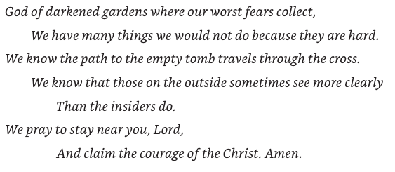

Watch Video Session #6

Divide people into 2 groups for listening – Group 1 will look at the perspective of Jesus and Group 2 will reflect on the disciples’ perspective

Read Mark 14:32-42
³² They went to a place called Gethsemane; and he said to his disciples, ‘Sit here while I pray.’ ³³ He took with him Peter and James and John, and began to be distressed and agitated. ³⁴ And he said to them, ‘I am deeply grieved, even to death; remain here, and keep awake.’ ³⁵ And going a little farther, he threw himself on the ground and prayed that, if it were possible, the hour might pass from him. ³⁶ He said, ‘Abba,^{[a]} Father, for you all things are possible; remove this cup from me; yet, not what I want, but what you want.’ ³⁷ He came and found them sleeping; and he said to Peter, ‘Simon, are you asleep? Could you not keep awake one hour? ³⁸ Keep awake and pray that you may not come into the time of trial;^{[b]} the spirit indeed is willing, but the flesh is weak.’ ³⁹ And again he went away and prayed, saying the same words. ⁴⁰ And once more he came and found them sleeping, for their eyes were very heavy; and they did not know what to say to him. ⁴¹ He came a third time and said to them, ‘Are you still sleeping and taking your rest? Enough! The hour has come; the Son of Man is betrayed into the hands of sinners. ⁴² Get up, let us be going. See, my betrayer is at hand.’

Invite group 1 to comment
- besides what Jesus says, what might he be feeling and thinking in this scene?
- What tone of voice do you think he uses?
Invite Group 2 to comment
- The disciples don’t comment, but what might they be feeling and thinking?
- Why do they fall asleep?
Reenact the scene with internal monologues
Assign:
- Jesus
- Jesus internal monologue
- Disciples (Peter, James, John)
- Narrator
Narrator | They went to a place called Gethsemane;  and he said to his disciples,
Jesus | ‘Sit here while I pray.’
Narrator | He took with him Peter and James and John, and began to be distressed and agitated. ³⁴ And he said to them,
Jesus | ‘I am deeply grieved, even to death; remain here, and keep awake.’
Pause for Internal Monologues
Narrator | And going a little farther, he threw himself on the ground and prayed that, if it were possible, the hour might pass from him.  He said,
Jesus | ‘Abba,^{[a]} Father, for you all things are possible; remove this cup from me; yet, not what I want, but what you want.’
Pause for Internal Monologues
Narrator | He came and found them sleeping; and he said to Peter,
Jesus | ‘Simon, are you asleep? Could you not keep awake one hour? Keep awake and pray that you may not come into the time of trial;^{[b]} the spirit indeed is willing, but the flesh is weak.’
 | And again he went away and prayed, saying the same words. And once more he came and found them sleeping, for their eyes were very heavy; and they did not know what to say to him. He came a third time and said to them,
 | ‘Are you still sleeping and taking your rest? Enough! The hour has come; the Son of Man is betrayed into the hands of sinners. Get up, let us be going. See, my betrayer is at hand.’
Pause for Internal Monologues

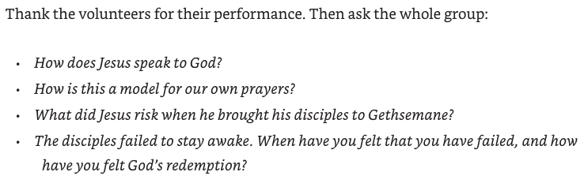

Consider Non-Violence

When the disciples finally wake up, they respond with violence to the arrest of Jesus. Christians have always struggled with how to respond to injustices, including the use of violence.

It has been said, “Christians should always seek an alternative to violence.”
But we also need to consider, What happens when alternatives fail?

Read Luke 22:47-53
⁴⁷ While he was still speaking, suddenly a crowd came, and the one called Judas, one of the twelve, was leading them. He approached Jesus to kiss him; ⁴⁸ but Jesus said to him, ‘Judas, is it with a kiss that you are betraying the Son of Man?’ ⁴⁹ When those who were around him saw what was coming, they asked, ‘Lord, should we strike with the sword?’ ⁵⁰ Then one of them struck the slave of the high priest and cut off his right ear. ⁵¹ But Jesus said, ‘No more of this!’ And he touched his ear and healed him. ⁵² Then Jesus said to the chief priests, the officers of the temple police, and the elders who had come for him, ‘Have you come out with swords and clubs as if I were a bandit? ⁵³ When I was with you day after day in the temple, you did not lay hands on me. But this is your hour, and the power of darkness!’

Read John 18:1-11
18 After Jesus had spoken these words, he went out with his disciples across the Kidron valley to a place where there was a garden, which he and his disciples entered. ² Now Judas, who betrayed him, also knew the place, because Jesus often met there with his disciples. ³ So Judas brought a detachment of soldiers together with police from the chief priests and the Pharisees, and they came there with lanterns and torches and weapons. ⁴ Then Jesus, knowing all that was to happen to him, came forward and asked them, ‘For whom are you looking?’ ⁵ They answered, ‘Jesus of Nazareth.’^{[a]} Jesus replied, ‘I am he.’^{[b]} Judas, who betrayed him, was standing with them. ⁶ When Jesus^{[c]} said to them, ‘I am he’,^{[d]} they stepped back and fell to the ground. ⁷ Again he asked them, ‘For whom are you looking?’ And they said, ‘Jesus of Nazareth.’^{[e]} ⁸ Jesus answered, ‘I told you that I am he.^{[f]} So if you are looking for me, let these men go.’ ⁹ This was to fulfil the word that he had spoken, ‘I did not lose a single one of those whom you gave me.’ ¹⁰ Then Simon Peter, who had a sword, drew it, struck the high priest’s slave, and cut off his right ear. The slave’s name was Malchus. ¹¹ Jesus said to Peter, ‘Put your sword back into its sheath. Am I not to drink the cup that the Father has given me?’
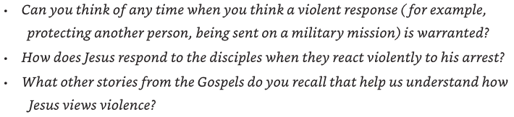
Consider Risk-taking
People in some vocations have to take significant risks. (firefighters, health workers, policing, military, etc)
What are some of the challenges and risks for people in risky vocations?
What prayers do you imagine people in such roles might pray?

Invite the members of the group to contribute some lines for a group prayer for people facing risks…

Closing Activity
What is something you learnt or developed from studying Jesus’ Passion over the last few weeks?

How do you feel challenged to take new risks on behalf of God’s Kingdom?
Can you share a hope for yourself or the world?

Closing Prayer

