A-J Study – Week 5
Session 5. THE LAST SUPPER
RISKING THE LOSS OF FRIENDS
Session Goals
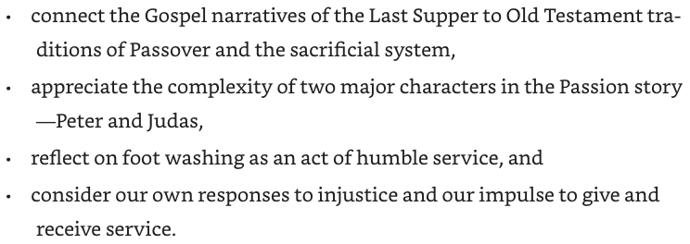

Opening Activity – Remember a Special Meal

Invite people to remember a special meal with family or friends. It might have been a Christmas or a big birthday or an engagement or Chinese New Year…
Thank about who was present, what food, decorations, any special words spoken, where you sat, who did the preparation…
Each person has 90 seconds to share (have a timekeeper)

Ask the group:
- How were these special meals different from everyday meals?
- Why do you think meals are a big part of celebrations?
- How are meals part of the life of our community of faith?
Opening Prayer

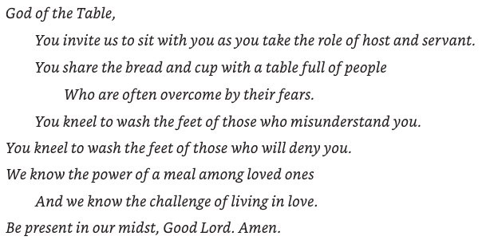
Watch Video Session #5

Read the story of the Passover – Exodus 12:21-28
²¹ Then Moses called all the elders of Israel and said to them, ‘Go, select lambs for your families, and slaughter the passover lamb. ²² Take a bunch of hyssop, dip it in the blood that is in the basin, and touch the lintel and the two doorposts with the blood in the basin. None of you shall go outside the door of your house until morning. ²³ For the Lord will pass through to strike down the Egyptians; when he sees the blood on the lintel and on the two doorposts, the Lord will pass over that door and will not allow the destroyer to enter your houses to strike you down. ²⁴ You shall observe this rite as a perpetual ordinance for you and your children. ²⁵ When you come to the land that the Lord will give you, as he has promised, you shall keep this observance. ²⁶ And when your children ask you, “What do you mean by this observance?” ²⁷ you shall say, “It is the passover sacrifice to the Lord, for he passed over the houses of the Israelites in Egypt, when he struck down the Egyptians but spared our houses.”’ And the people bowed down and worshipped.
²⁸ The Israelites went and did just as the Lord had commanded Moses and Aaron.
Discuss
Thinking about Exodus (Chapters 1-11):
- What was the oppression that concerned God?
- What was God going to do to address it?
- What was the purpose of the Passover sacrifice?
Thinking about John 1:19-37
- What does John the Baptizer call Jesus in this passage?
- How does the title relate to the Passover story in Exodus 12?
- How does this understanding of who Jesus is change the understanding of the Passover offering?
Read Mark 14:66-72
⁶⁶ While Peter was below in the courtyard, one of the servant-girls of the high priest came by. ⁶⁷ When she saw Peter warming himself, she stared at him and said, ‘You also were with Jesus, the man from Nazareth.’ ⁶⁸ But he denied it, saying, ‘I do not know or understand what you are talking about.’ And he went out into the forecourt.^{[a]} Then the cock crowed.^{[b]} ⁶⁹ And the servant-girl, on seeing him, began again to say to the bystanders, ‘This man is one of them.’ ⁷⁰ But again he denied it. Then after a little while the bystanders again said to Peter, ‘Certainly you are one of them; for you are a Galilean.’ ⁷¹ But he began to curse, and he swore an oath, ‘I do not know this man you are talking about.’ ⁷² At that moment the cock crowed for the second time. Then Peter remembered that Jesus had said to him, ‘Before the cock crows twice, you will deny me three times.’ And he broke down and wept.

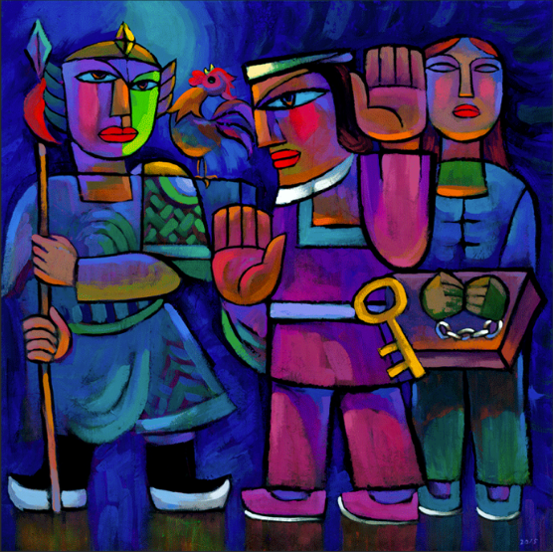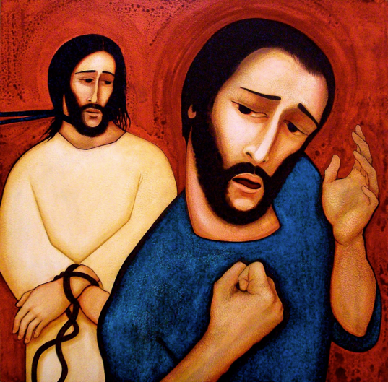

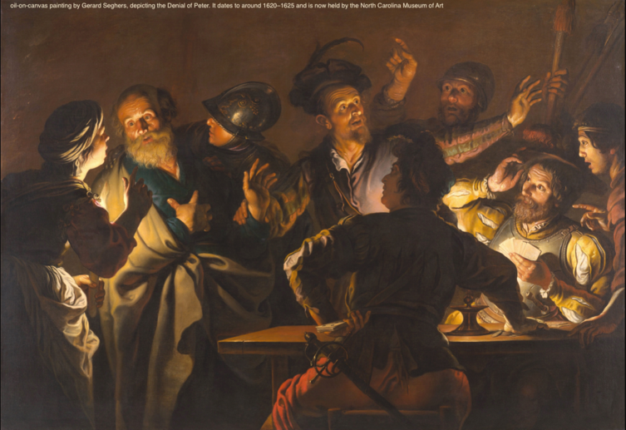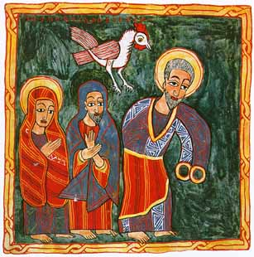

When we see these images, how do we sense Peter’s fear?

Thinking back to dinners…

- Did anyone ever say anything at a dinner that I found surprising or even offensive? How did I react?
- How is my fear preventing me from speaking out on behalf of someone or something that is precious to me?
- If I were not afraid, what would I be doing?

We read some of AJ together…
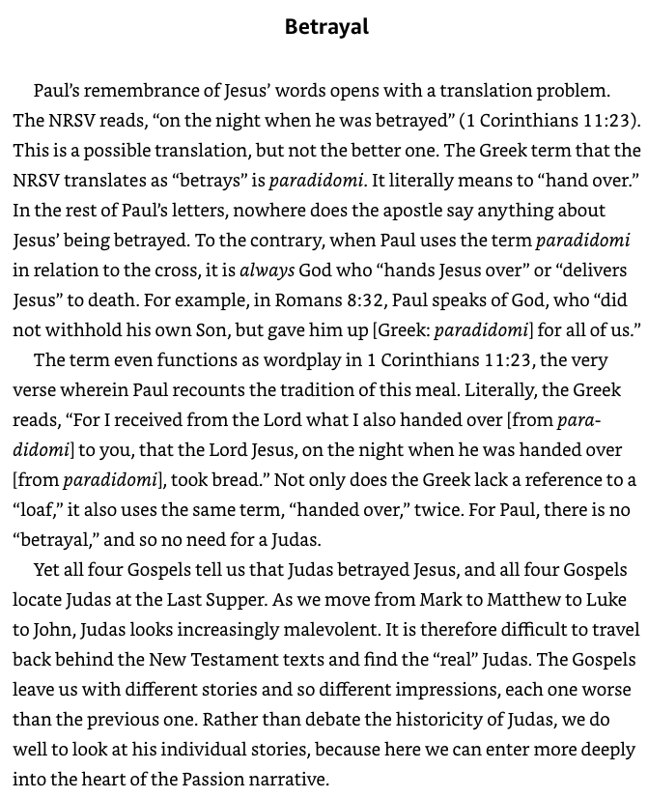

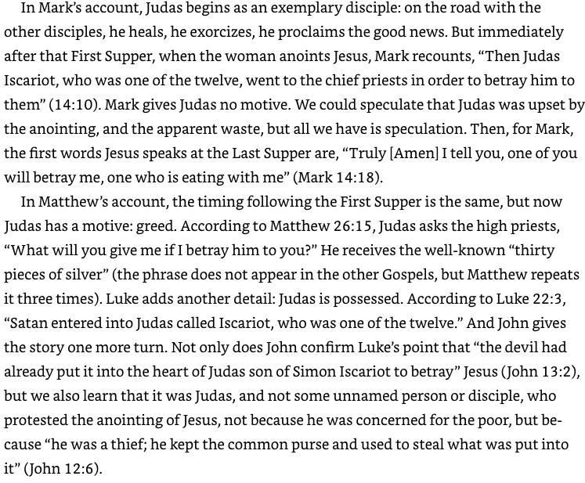
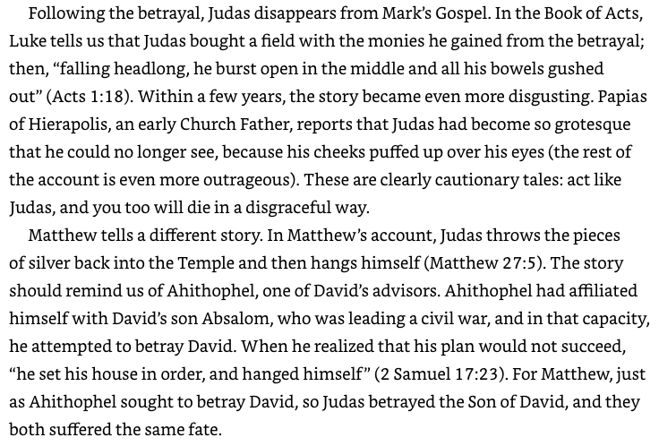
Had you previously noticed the differences between the Gospel versions of Judas?
Do you have a preference for a particular Gospel version of Judas?
Why do you think Judas betrayed Jesus?

Consider Acts of Service

Think about how you have experienced someone doing an act of service for you?
Share brief examples

In John’s Gospel, Jesus’ act of foot-washing follows the act of the woman who anoints Jesus.
How is Jesus washing of the disciples’ feet similar to the woman’s act?

Reflection - Think about your neighbours:
- Do you know your neighbours’ names?
- What do I know about my neighbours?
- What needs might my neighbours have that I might meet?
- If my neighbours were to offer a gift of service or help, how would it make me feel?
Ask the group
- What is something you could do this week to deepen your relationship with your neighbours?
Closing Activity
Make plans to be able to ‘share bread’ together…
When could this group gather for a meal or a cuppa?

Share – how is God moving through this Lenten journey with you?

Closing Prayer

Christ – we give thanks for times past
when we could share together freely with others.
We ask you to open our lives again
to new possibilities of contact and gathering.
We ask for deeper meaning and appreciation
to come as we regather with others.
We pray for those who are fearful or unable to gather with us.
We pray that we might give and receive
with care, generosity and consciousness about each other’s wellbeing.
We receive what you have to give,
and go forth to give ourselves. Amen

