A-J Study – Week 4
Session 4 First Dinner
RISKING REJECTION
Session Goals
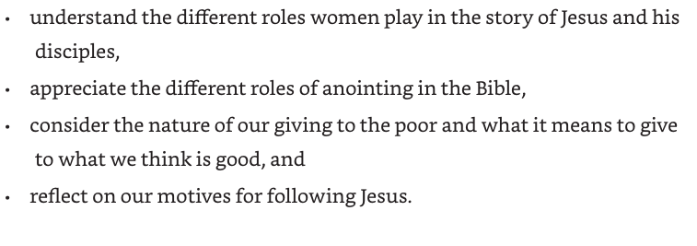
Opening Activity -
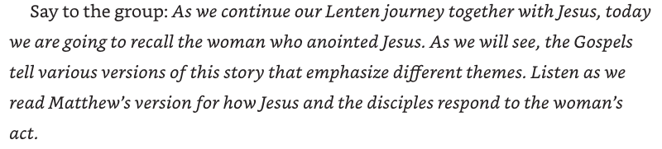
Read Matthew 26:6-13 The Anointing at Bethany
⁶ Now while Jesus was at Bethany in the house of Simon the leper,^{[a]} ⁷ a woman came to him with an alabaster jar of very costly ointment, and she poured it on his head as he sat at the table. ⁸ But when the disciples saw it, they were angry and said, ‘Why this waste? ⁹ For this ointment could have been sold for a large sum, and the money given to the poor.’ ¹⁰ But Jesus, aware of this, said to them, ‘Why do you trouble the woman? She has performed a good service for me. ¹¹ For you always have the poor with you, but you will not always have me. ¹² By pouring this ointment on my body she has prepared me for burial. ¹³ Truly I tell you, wherever this good news^{[b]} is proclaimed in the whole world, what she has done will be told in remembrance of her.’
discuss
- How do the disciples respond to this woman?
- How does Jesus respond?
- How do we respond to some good act done for us?
Anointing
Invite people to get a bit of oil – olive oil or cooking oil will do – or moisturizer…
Invite them to make the sign of the cross on the back of their hand as someone else says the words: May the peace of Christ be with you.

Opening Prayer
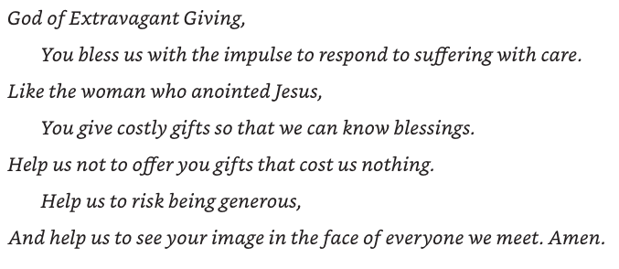

Intro the AJ Video
Play Video – 8-10 minutes
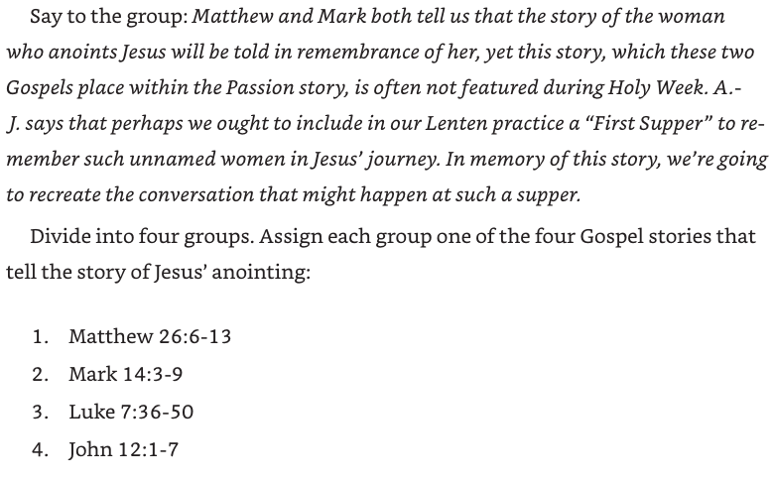
If working as individuals or pairs, give people time to read their assigned passage to themselves, then discuss together, drawing from the reading they have just done…
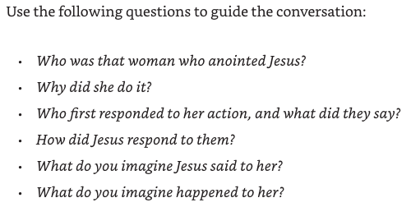
In Chapter 4 of the Study Book, there are three terms:
- Christos
- Mashiach
- Myrizo
What kind of anointing is in each of the following passages…

1 Samuel 10:1 10 ¹ Samuel took a phial of oil and poured it on his head, and kissed him; he said, ‘The Lord has anointed you ruler over his people Israel. You shall reign over the people of the Lord and you will save them from the hand of their enemies all around. Now this shall be the sign to you that the Lord has anointed you ruler^{[a]} over his heritage:

1 Samuel 16:13 ¹³ Then Samuel took the horn of oil, and anointed him in the presence of his brothers; and the spirit of the Lord came mightily upon David from that day forward. Samuel then set out and went to Ramah.

1 Kings 1:39 ³⁹ There the priest Zadok took the horn of oil from the tent and anointed Solomon. Then they blew the trumpet, and all the people said, ‘Long live King Solomon!’

2 Kings 9:6 ⁶ So Jehu^{[a]} got up and went inside; the young man poured the oil on his head, saying to him, ‘Thus says the Lord the God of Israel: I anoint you king over the people of the Lord, over Israel.

Mark 14:8

⁸ She has done what she could; she has anointed my body beforehand for its burial.

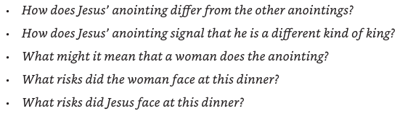
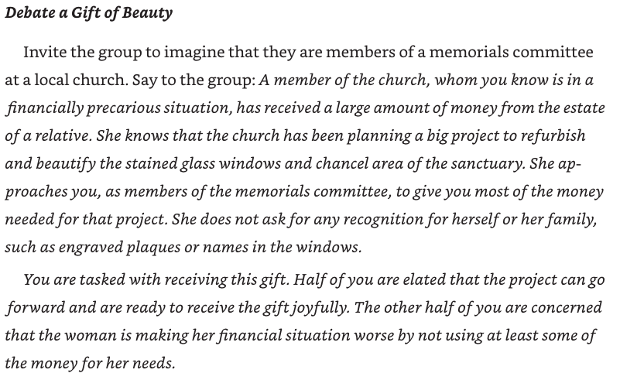
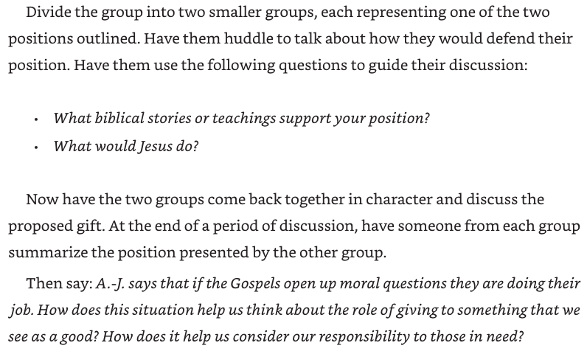
Motives for Following Jesus…
AJ introduces us to the possible motives the women in the Gospel stories had for following Jesus…
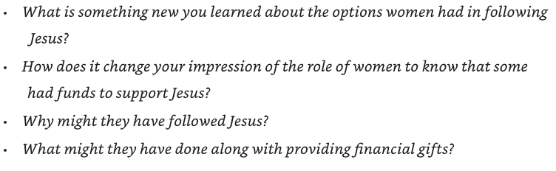
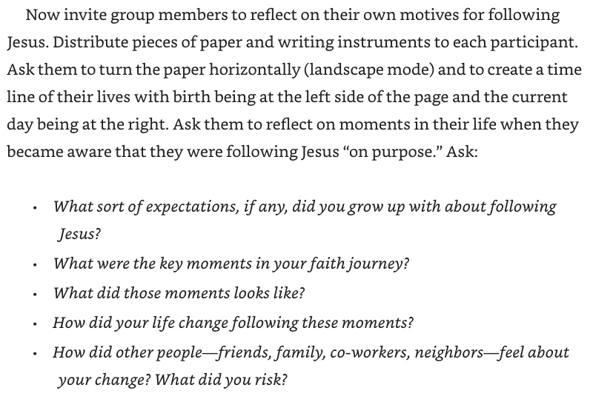
One of the purposes of being in a faith community or fellowship is so that we can support each other along the way, yet our stories and experiences are very different from each other. Also, we are all at different life stages, but is there anything you would like to share about doing that exercise and what we could do to support one another on the journey?

Closing Activity
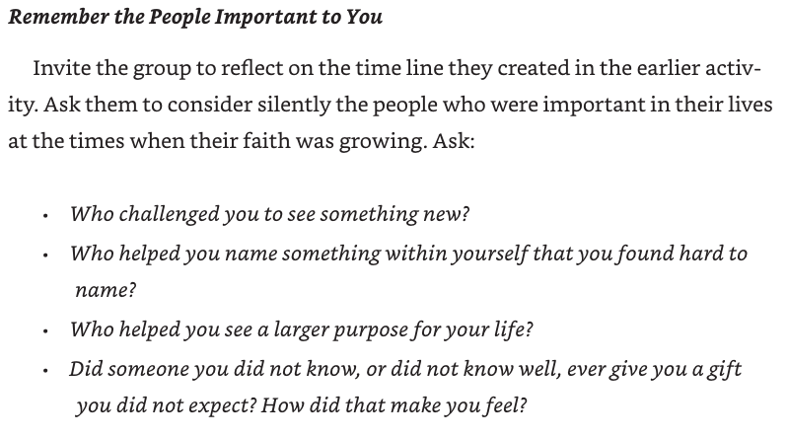
Let’s give thanks for the people we have been thinking about – you might like to name them aloud…

Closing Prayer

