A-J Study – Week 2
Session 3 TEACHINGS
RISKING CHALLENGE
Session Goals
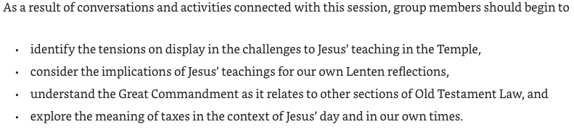
Foundation Passage Mark 12:28-31
²⁸ One of the scribes came near and heard them disputing with one another, and seeing that he answered them well, he asked him, ‘Which commandment is the first of all?’ ²⁹ Jesus answered, ‘The first is, “Hear, O Israel: the Lord our God, the Lord is one; ³⁰ you shall love the Lord your God with all your heart, and with all your soul, and with all your mind, and with all your strength.” ³¹ The second is this, “You shall love your neighbour as yourself.” There is no other commandment greater than these.’

Opening Activity - Ask people to grab their wallets and pull out some money…
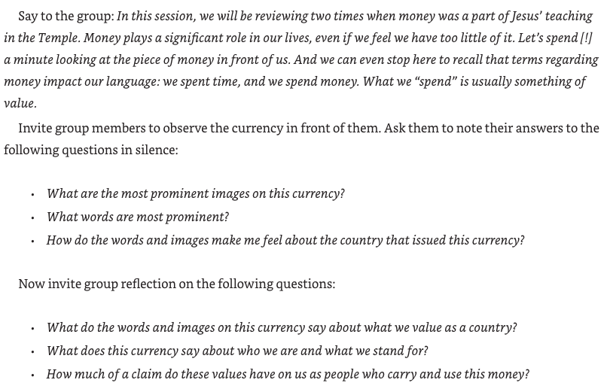

Opening Prayer
We are following you, Jesus,
down paths that challenge our allegiances and risk our comforts.
We are watching to see what you will do.
Will you say the expected thing or do the unexpected?
Will you be true to whom we assume you are
Or will you surprise us once again?
We see the costly journey of your Passion
And we wonder at the risks you took.
We want to believe like you believe
In the power of God’s love. Amen [Truly]

Intro the AJ Video
This week, in the video, and in Chapter 3 of the book, AJ focuses on Jesus’ teachings in the Temple and the risks he takes in delivering his message and confronting challengers.
Play Video – 8-10 minutes
Have someone Read aloud Mark 12:28-34
²⁸ One of the scribes came near and heard them disputing with one another, and seeing that he answered them well, he asked him, ‘Which commandment is the first of all?’ ²⁹ Jesus answered, ‘The first is, “Hear, O Israel: the Lord our God, the Lord is one; ³⁰ you shall love the Lord your God with all your heart, and with all your soul, and with all your mind, and with all your strength.” ³¹ The second is this, “You shall love your neighbour as yourself.” There is no other commandment greater than these.’ ³² Then the scribe said to him, ‘You are right, Teacher; you have truly said that “he is one, and besides him there is no other”; ³³ and “to love him with all the heart, and with all the understanding, and with all the strength”, and “to love one’s neighbour as oneself”,—this is much more important than all whole burnt-offerings and sacrifices.’ ³⁴ When Jesus saw that he answered wisely, he said to him, ‘You are not far from the kingdom of God.’ After that no one dared to ask him any question.
Jesus sums up the Law by lifting up two Old Testament commands as primary: loving God and loving our neighbour.
Divide into two groups to read and reflect on the following questions
Group or pair 1 Deuteronomy 6
Group or pair 2 Leviticus 19
- What verses contain the command you are looking for?
- Given the context, why does this command seem important?
- What other kinds of love are talked about in this Chapter?
After there has been time in small groups or pairs, ask:
- What did you learn about what it means to love God or your neighbour?
- If we took these commands seriously, what would have to change in our lives and our churches?
- What would we need to risk to make changes?
The Meaning of the Greatest Commandment
Read from AJ’s book:
Thus, the scribe in Mark 12, who is impressed with Jesus’ teaching, asks an earnest rather than snarky question, “Which commandment is the first of all?” (v. 28). Which is primary? Which should be the guide by which others are to be understood? The scribe wants to know.
Jesus provides him an answer that would have been familiar. He begins by citing Deuteronomy 6:4-5, “The first is, ‘Hear, O Israel: the Lord our God, the Lord is one; you shall love the Lord your God with all your heart, and with all your soul, and with all your mind, and with all your strength’ ” (Mark 12: 29-30). This verse is part of Judaism’s daily liturgy, and I cannot remember a time when I did not know these words. Yet when I read this verse in the Gospels, I was surprised to find the reference to “all your mind,” because that is not in Deuteronomy. Jesus not only cites the verse, he adds to it. How Jewish! One takes a commandment, and then extends it to be sure that it is followed appropriately. In Judaism, this practice is known as “building a fence around the Law”; the practice helps us better follow what God wants us to do.
Then Jesus cites Leviticus 19:18, “You shall love your neighbour as yourself.” We have seen these two verses put together earlier in the Gospel tradition. They are cited not by Jesus, but by the lawyer to whom Jesus will tell the famous parable of the good Samaritan.
The scribe is impressed. He acknowledges Jesus’ response by repeating it and then concluding, “This is much more important than all whole burnt offerings and sacrifices” (Mark 12:33). Of course it is; no one would doubt that. There are greater commandments and lesser commandments. All are important, but some have greater weight than others.
Levine, Amy-Jill. Entering the Passion of Jesus [Large Print] (pp. 79-80). Abingdon Press. Kindle Edition.

Discuss the role of the Greatest Commandment in relation to the rest of ‘The Law’…
- What does it mean to die by the Law?
- What does it mean to live by the Law?
- When has following God’s commands helped you feel freedom of joy?

Read The Widow’s Offering (Mark 12:41-44)
⁴¹ He sat down opposite the treasury, and watched the crowd putting money into the treasury. Many rich people put in large sums. ⁴² A poor widow came and put in two small copper coins, which are worth a penny. ⁴³ Then he called his disciples and said to them, ‘Truly I tell you, this poor widow has put in more than all those who are contributing to the treasury. ⁴⁴ For all of them have contributed out of their abundance; but she out of her poverty has put in everything she had, all she had to live on.’

Activity: Improvisation re-enactment…
Assign roles:
- Jesus, teaching in the Temple
- Rich people/person
- Widow with 2 coins
- Disciple/s
Give them a few moments to think about and write themselves a couple of lines of what they might say in the situation.
Ask them to perform their reenactment.
When they have finished, ask:
- What did you notice in the improv that you have not noticed in the reading?
- What do you think we are supposed to think about the widow?
- In what ways is her gift a sign of what Jesus is giving in his Passion journey?
Read what A-J writes about the system of reciprocity…
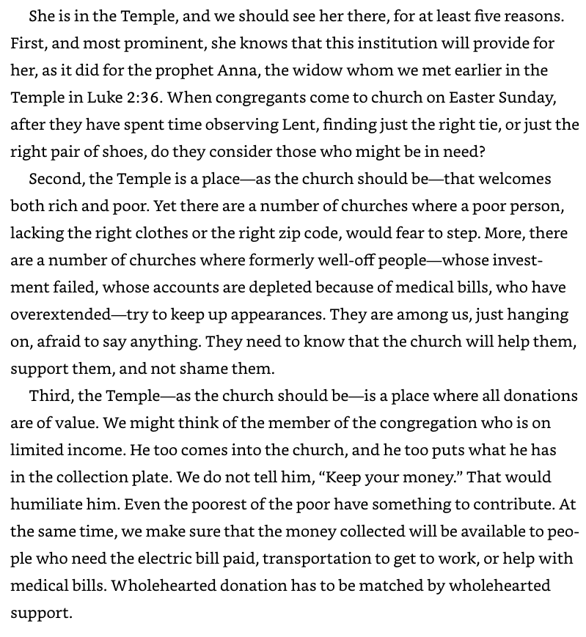
Discuss
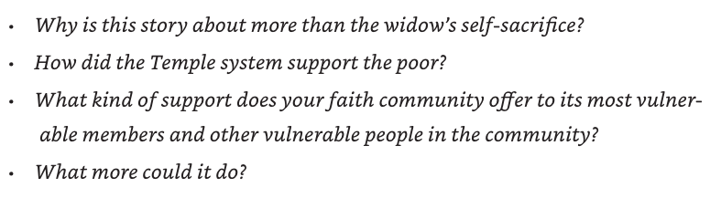

Consider the Pharisees and Herodians
Read Mark 12:13-17
¹³ Then they sent to him some Pharisees and some Herodians to trap him in what he said. ¹⁴ And they came and said to him, ‘Teacher, we know that you are sincere, and show deference to no one; for you do not regard people with partiality, but teach the way of God in accordance with truth. Is it lawful to pay taxes to the emperor, or not? ¹⁵ Should we pay them, or should we not?’ But knowing their hypocrisy, he said to them, ‘Why are you putting me to the test? Bring me a denarius and let me see it.’ ¹⁶ And they brought one. Then he said to them, ‘Whose head is this, and whose title?’ They answered, ‘The emperor’s.’ ¹⁷ Jesus said to them, ‘Give to the emperor the things that are the emperor’s, and to God the things that are God’s.’ And they were utterly amazed at him.
Jesus is aware of the hypocrisy of those who question him, but the Pharisees and Herodians had interests that are familiar to us. As we read, let’s note:
- What were the interests of each group?
- How do you think they would answer the question they asked Jesus?
- In what ways are we asking similar questions today?
AJ writes… [discuss the questions after reading]
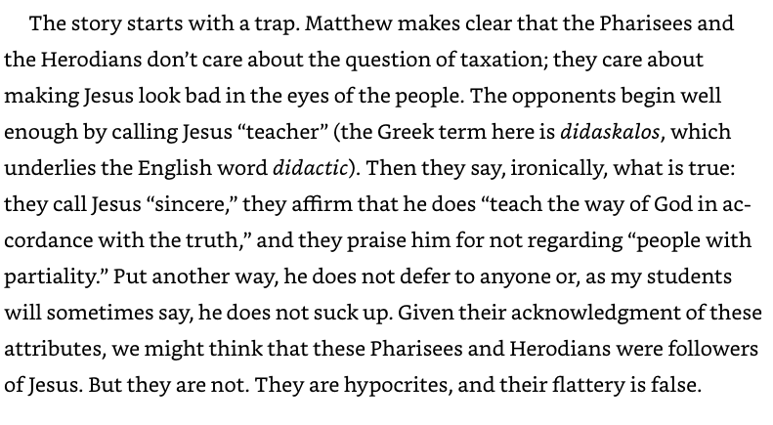
Reflect on our Theme of Money
Think about what you spent money on in the last few days.
(you are not being asked to share details)
Personal reflection:
- How typical was this of your spending habits?
- What do your spending habits reveal about what you value?
- To whom or what are we giving our money?
For discussion:
- What steps might you take?
