Readings Micah 6:1-8
Hear now what YHWH says:
“Come, plead your case before the mountains, and let the hills hear your voice!
Listen to YHWH’s indictment, you mountains and you enduring foundations of the earth; for YHWH has a dispute with the people, and is putting Israel on trial.
O my people, what have I done to you? How have I wearied you? Give me an answer!
For I brought you up from the land of Egypt, and redeemed you from the house of slavery; and I sent Moses to lead you, and Aaron, and Miriam!
My people, call to mind the plans devised by the ruler Balak of Moab, and how Balaam ben-Beor answered him! Remember the journey from Shittim to Gilgal, and recall how YHWH brought you justice!”
“What shall I bring when I come before YHWH, and bow down before God on high?”
you ask. “Am I to come before God with burnt offerings? With year-old calves?
Will YHWH be placated by thousands of rams or ten thousand rivers of oil?
Should I offer my firstborn for my wrongdoings—
the fruit of my body for the sin of my soul?”
Listen here, mortal: God has already made abundantly clear what “good” is,
and what YHWH needs from you:
simply do justice, love kindness, and humbly walk with your God.
Priests for Equality. The Inclusive Bible (pp. 1095-1096). Sheed & Ward. Kindle Edition.

Matthew 5:1-12
When Jesus saw the crowds, he went up on the mountainside, and after he sat down and the disciples had gathered around, Jesus began to teach them:
“Blessed are those who are poor in spirit: the kindom of heaven is theirs.
Blessed are those who are mourning: they will be consoled.
Blessed are those who are gentle: they will inherit the land.
Blessed are those who hunger and thirst for justice: they will have their fill.
Blessed are those who show mercy to others: they will be shown mercy.
Blessed are those whose hearts are clean: they will see God.
Blessed are those who work for peace: they will be called children of God.
Blessed are those who are persecuted because of their struggle for justice:
the kindom of heaven is theirs.
“You are fortunate when others insult you and persecute you, and utter every kind of slander against you because of me. Be glad and rejoice, for your reward in heaven is great; they persecuted the prophets before you in the very same way.
Priests for Equality. The Inclusive Bible (p. 2130). Sheed & Ward. Kindle Edition.

For words showing us truth, Thanks be to God.

Message Justice in our Land

The prophet Micah tells the people of YHWH’s call to act justly, love mercy and walk humbly with your God.
The Messiah, Jesus Christ, tells people they are blessed when they struggle for justice, when they show mercy and when they are gentle.

Both Micah and Jesus talk about the Land.
Micah tells us to plead our case to the hills and mountains.
Jesus chooses to be on a mountain when he tells people what it takes to inherit the land. Most of the people present would have been those who were dispossessed, either of their lands or their freedoms or the capacity for self-determination.

Justice is not measured by what people think or what they say, but the real lived experience of people in place, in time, in embodied relationships.

Our experiences of justice in this land is very different, depending on your background. It also depends on your identity and your relationship with the land. Is this a place of possession or dispossession? Is this a place of liberation and celebration OR a place of loss and sorrowing? Is this a place of refuge?

To explain what I mean about our identity and relationship with country,
I have two stories…

- Where are you from?
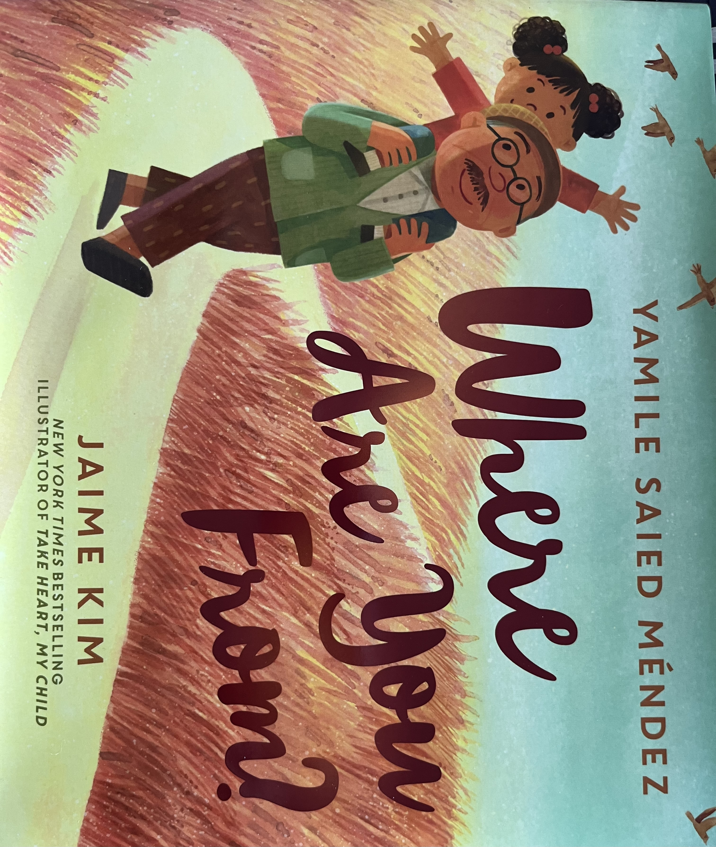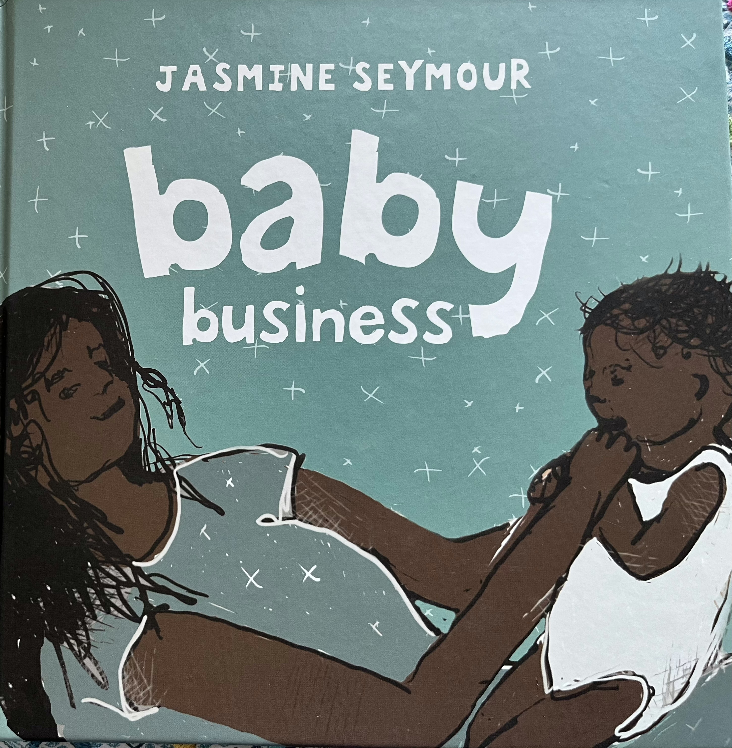
- Baby Business

What contrasts do you notice between the stories?
…

As a child, as a teenager, as a young woman, as a mature adult, I have always been asked where I am from. Mostly, I’m happy to answer, but occasionally, particularly if I have said, “I am Australian”, someone questions it, asking, “Where are you really from?” As a child, people were often wondering, was I a Vietnamese boat refugee?

People would often stereotype us – oh, you Chinese always…. Or, among my friends – oh, Sri Lankans! … or Lebs or Wogs or Koreans or whatever…
The first step in dehumanizing an identity group is to stereotype the people in it.
Many indigenous peoples in Australia have lost their connection with Country, but the Healing of the Land and our relationships with Aboriginal and Torres Strait Islanders is connected with supporting a re-establishment of connection between First Peoples and Country, Waterways and Language.

Work on reclaiming languages and stories is a beginning. But the inability of one of the wealthiest and most educated countries in the world to make real headway in ‘closing the gap’ is shameful. It is a glaring and obvious sin in our nation.

We talk about the country of the ‘fair go’ but the ‘fair go’ does not extend to all – it seems to be only for some.
Over the last two decades there have been a series of MEMES that help explain that EQUALITY is not the same as FAIR…

1
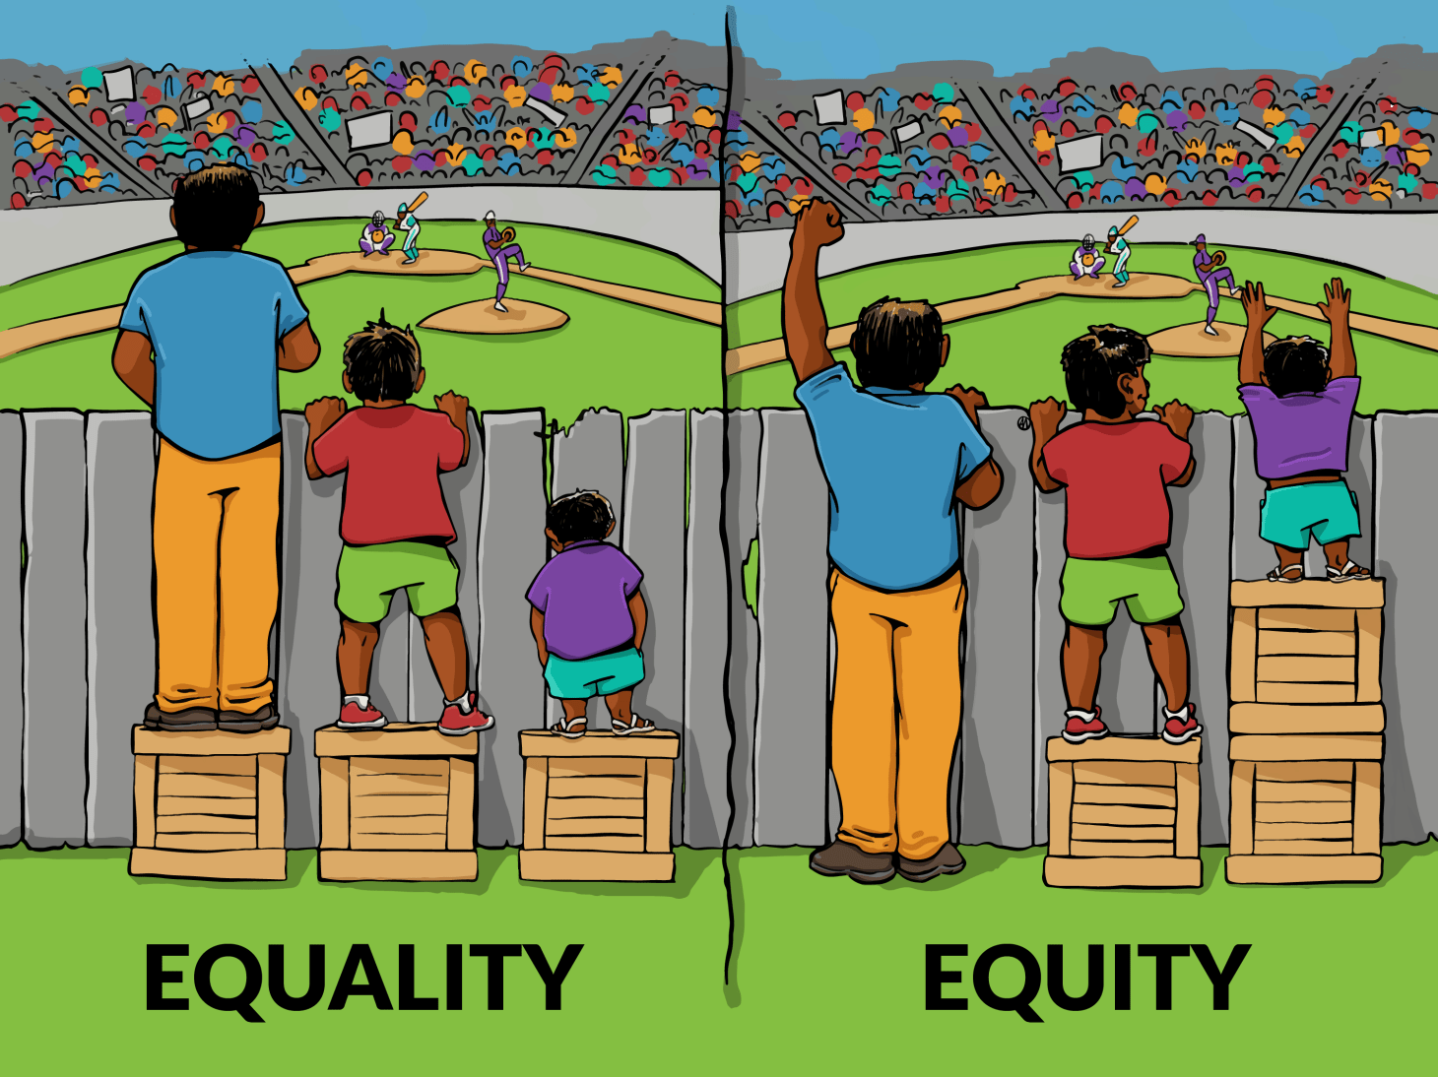
Here is the difference between Equality and Equity…
There are inherent differences in our capacities to access resources.
It is illustrated here with people of different heights trying to see over the same fence. Giving them each a same sized box to stand on only helps some. The disadvantage that some experience is too great. More assistance is needed for the most disadvantaged…

2
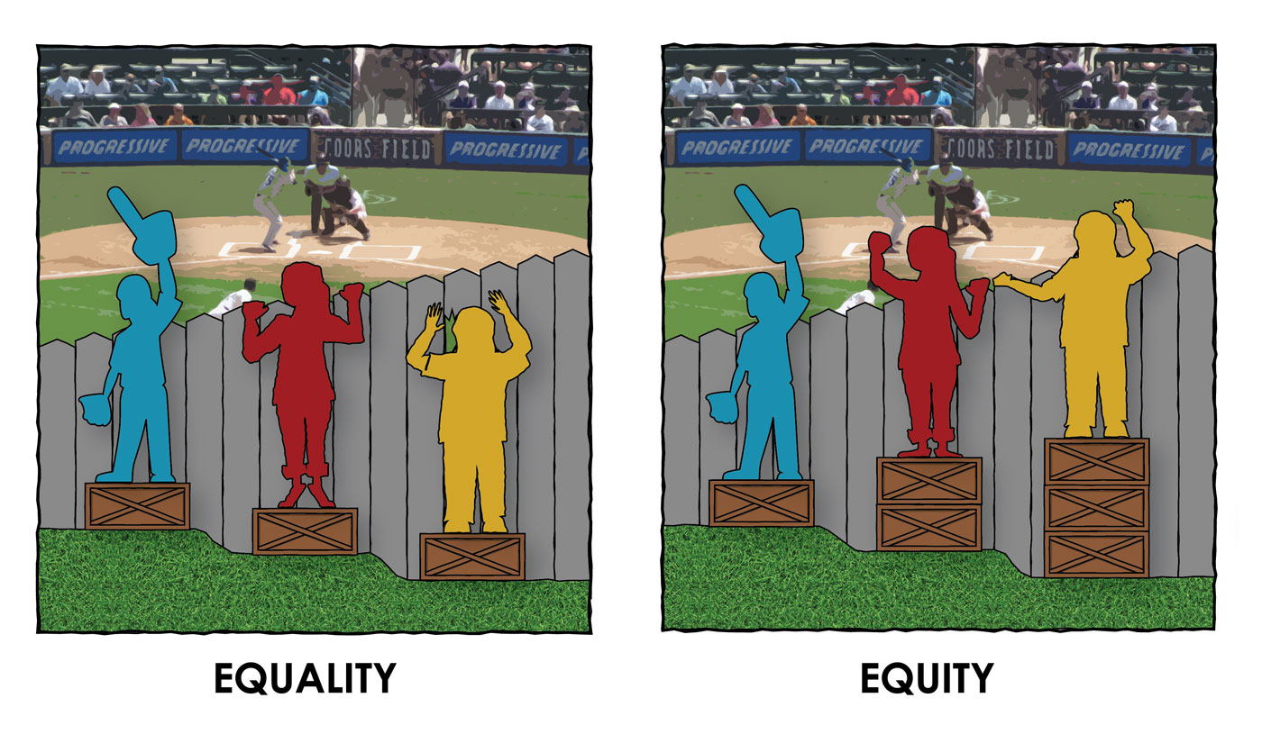
Then, of course, there is the illustration where it is not just the height difference, but the difference in the ground they stand on.

3.
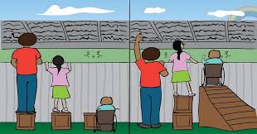
A third meme shows the need for different thinking about the kinds of assistance, particularly when confronted with disability and access issues.

4
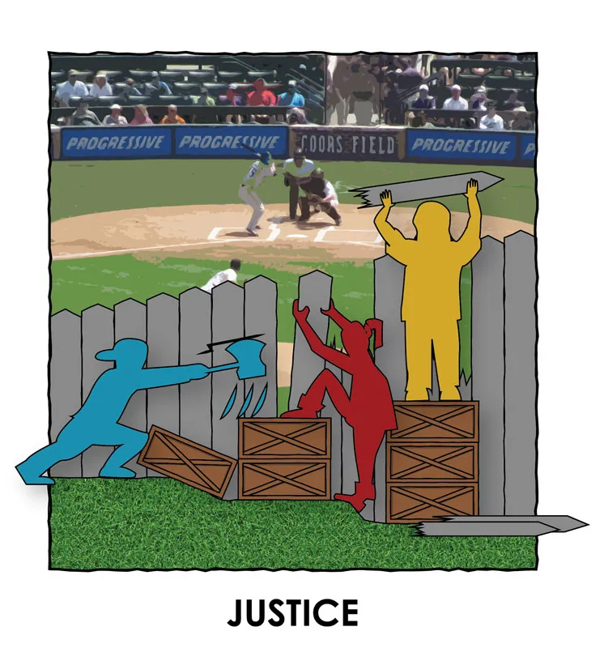
Then there is the idea of justice and the possibility of removing obstacles…

5
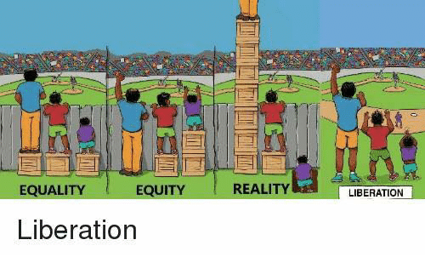
This final meme shows a summary – Equality (which leaves some disadvantaged), Equity (which is an ideal, not often experienced), Reality (where those who have seem to have so much and those who don’t will never be able to get out of a hole) and Justice (where the obstacles get removed)

6
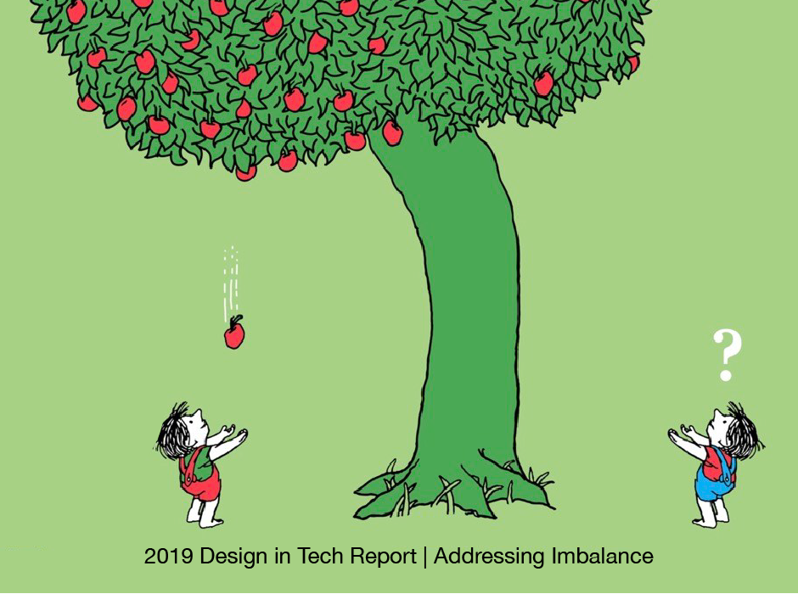
In 2019, further MEMES appeared about addressing imbalance.
We have a tree, tipped slightly to one side, so the person on that side is more likely to be able to catch the falling fruit.
7
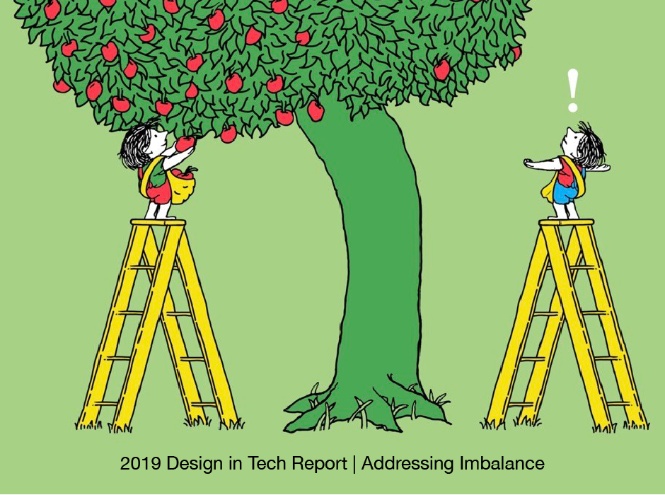
People on both sides get a ladder, but it is only tall enough to help the person on one side.
8
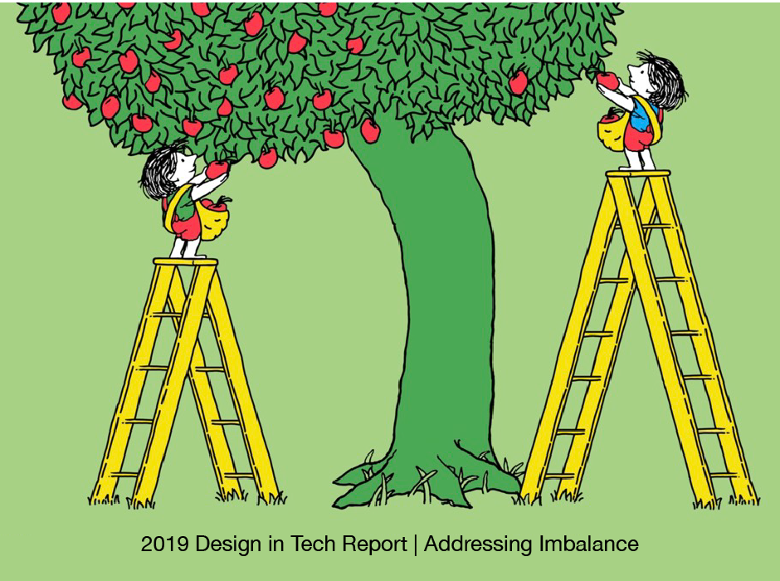
Of course, you could solve that by getting a taller ladder for the side that needs it… OR

9
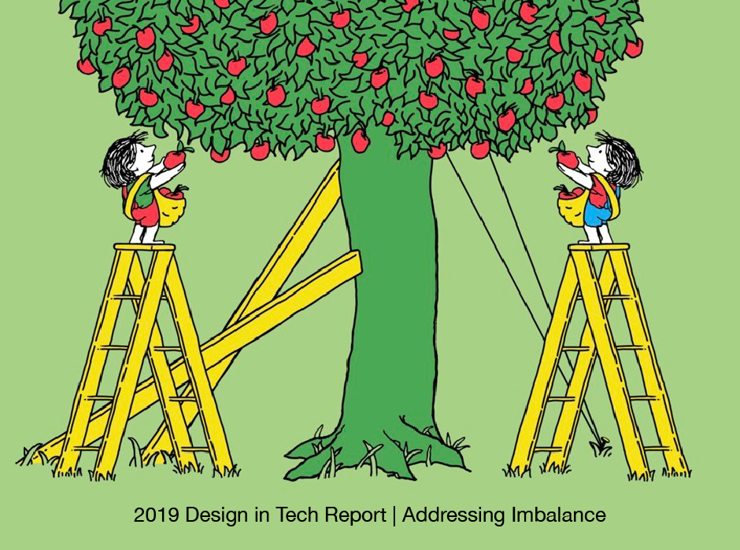
You could also support the straightening of the tree, so that the fruit could become accessible on both sides…

Justice in our Land, in our community and even in this congregation, has got to start with understanding advantage and disadvantage. We are not all equal. We do not all have access to the same resources. We do not all have the same educational opportunities. We do not all live in our own home. Many of our community face extraordinary struggles. Many in our community have overcome many struggles. So, we need to be a place of compassion and build up the possibility for the most vulnerable among us to blossom into the people God is calling them to be.

When Jesus talks about those who are blessed and included and affirmed in God’s community, Jesus talks about:
the poor, those who mourn, the gentle,
those who hunger and thirst for justice, those who show mercy,
those whose hearts are clean, those who work for peace,
those who are persecuted because of their struggle for justice…

The broken and disadvantaged should be able to find their comfort and their encouragement here. If we are to act justly, love mercy and walk humbly with God, we will look for those among us who have the least and help them to be blessed out of the riches and privilege of those who have more. Those who are given a little, should share what they have. From those who are given more, more is expected.

So often, we compare ourselves only to those who are higher on the ladder above us. We don’t have as much as them, so we must be poor. We don’t look down where we might fear to fall. We can easily miss seeing that the comfort we experience is linked on the poverty of the dispossessed.

If, as a nation, we were to ensure that the First peoples had access to the best healthcare of all Australians, we would be building Dialysis centres in remote areas at enormous expense. We might need to forego a few stadiums and fireworks and festivals.

Justice in our land will take sacrifice and generosity and people who work for justice by modelling what the mercy of God looks like. The good news is this – God invites us to be part of God’s own justice making team wherever God places us. We are invited to participate in acts of compassion and mercy and advocacy.
We worship God in our giving.

