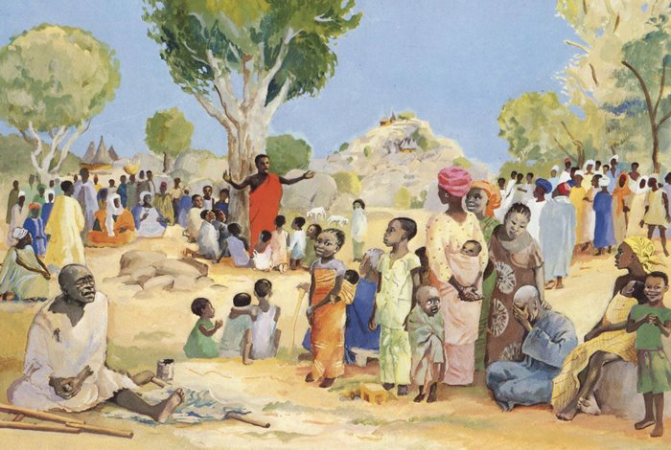
Justice, Mercy and Humility
Eastwood Uniting Church

9.30am, 29th January 2023,
with Rev Dr Amelia Koh-Butler.

Preparation [Music – Psalm 15 – Francesca LaRosa]

‘Ordinary time’ [colour Green] is a time for people to consider being disciple. The call to radical discipleship is a call to justice and advocacy. This week, we have been challenged to consider just relationships between 1st and 2nd Peoples in this land. What questions and concerns do you bring? How might we discover together, as a community of justice, what might be possible?

Call to Worship [Psalm 15:1-2] and Candle
여호와여, 누가 주의 성소에 들어갈 수 있으며 누가 주의 거룩한 산에 머물 수 있겠습니까?
² 정직하게 살고 옳은 일을 행하며 그 마음에 진실을 말하는 자
Herre, vem får fly till ditt tempel uppe på ditt heliga berg?
Jo, den som lever ett oklanderligt liv och alltid är uppriktig och talar sanning.
Who has the right to enter your tent, or to live on your holy mountain?
Those who conduct themselves with integrity and work for justice,
who speak the truth from their heart
耶和华啊，谁能住在你的圣所？ 谁能安居在你的圣山？
就是品行纯全，做事公正，说话诚实的人。

Acknowledgement and Welcome Warami nullawar mittigar! [Darug]

Song 1. When I needed a neighbour, were you there [Sidney Carter]

And the creed and the colour and the name don’t matter…

2. I was hungry and thirsty, were you there…

And the creed and the colour and the name don’t matter…

3. I was cold and naked, were you there…

4. When the crosses were burning, were you there…

5. When I needed a healer, were you there…

6. When they took me to prison, were you there…

7. Wherever you travel, I’ll be there…

Prayer
We confess the many injustices in our society.
We confess our complicity in letting things be, in failing to speak up.
We confess that sometimes we do the wrong thing.
We confess that sometimes we fail to do what is right.
We confess that without you, O God, our efforts can never be enough.
So, we ask for your grace, in the words Jesus taught us
(as we pray in our own languages)… The Lord’s Prayer

Assurance of Forgiveness
Thomas Aquinas wrote: “Mercy without justice is the mother of dissolution;
Justice without mercy is cruelty.”
We place our faith in a God who is both just and merciful.
We do not always see fairness straight away, when we wish for it,
but we are called to live into the promise that justice and mercy will be realised in the Kin-dom of Heaven to come.
God loves you. God forgives you. God claims you.
Thanks be to God! Amen.

Time for Everyone Scales of justice

Song I’ve got peace like a river https://www.youtube.com/watch?v=d6085sLXCMs
- I've got peace like a river [in my soul].
- I've got joy like a fountain [in my soul].
- I've got love like the ocean [in my soul].
- I’ve got peace, joy and love…

[Chinese go to Chapel]
Readings Micah 6:1-8
Hear now what YHWH says:
“Come, plead your case before the mountains, and let the hills hear your voice!
Listen to YHWH’s indictment, you mountains and you enduring foundations of the earth; for YHWH has a dispute with the people, and is putting Israel on trial.
O my people, what have I done to you? How have I wearied you? Give me an answer!
For I brought you up from the land of Egypt, and redeemed you from the house of slavery; and I sent Moses to lead you, and Aaron, and Miriam!
My people, call to mind the plans devised by the ruler Balak of Moab, and how Balaam ben-Beor answered him! Remember the journey from Shittim to Gilgal, and recall how YHWH brought you justice!”
“What shall I bring when I come before YHWH, and bow down before God on high?”
you ask. “Am I to come before God with burnt offerings? With year-old calves?
Will YHWH be placated by thousands of rams or ten thousand rivers of oil?
Should I offer my firstborn for my wrongdoings—the fruit of my body for the sin of my soul?”
Listen here, mortal: God has already made abundantly clear what “good” is, and what YHWH needs from you: simply do justice, love kindness, and humbly walk with your God.
Priests for Equality. The Inclusive Bible (pp. 1095-1096). Sheed & Ward. Kindle Edition.

Matthew 5:1-12
When Jesus saw the crowds, he went up on the mountainside, and after he sat down and the disciples had gathered around, Jesus began to teach them:
“Blessed are those who are poor in spirit: the kindom of heaven is theirs.
Blessed are those who are mourning: they will be consoled.
Blessed are those who are gentle: they will inherit the land.
Blessed are those who hunger and thirst for justice: they will have their fill.
Blessed are those who show mercy to others: they will be shown mercy.
Blessed are those whose hearts are clean: they will see God.
Blessed are those who work for peace: they will be called children of God.
Blessed are those who are persecuted because of their struggle for justice:
the kindom of heaven is theirs.
“You are fortunate when others insult you and persecute you, and utter every kind of slander against you because of me. Be glad and rejoice, for your reward in heaven is great; they persecuted the prophets before you in the very same way.
Priests for Equality. The Inclusive Bible (p. 2130). Sheed & Ward. Kindle Edition.

For words showing us truth, Thanks be to God.

Message Justice in our Land
Offering / Response Music – How long? [NCYC-Robin Mann]
Prayers
Give us the courage to accept the realities of our history
so that we may build a better future for our nation.
Teach us to respect all cultures. Teach us to care for our land and waters.
Help us to share justly the resources of this land.
Help us to bring about spiritual and social change
to improve the quality of life for all peoples in our communities,
especially the disadvantaged.
Help all young people to find true dignity and self-esteem by your Spirit.
May your power and love be the foundations on which we:
walk together as First and Second Peoples;
and build our families, our communities and our nation.

We pray for people with special needs… [silence]
We pray for those who suffer the injustice of war and displacement.
We pray for those who commit injustice – that you, merciful God,
would repair their hearts and restore their souls,
so that they might become peacemakers and healers.
We pray for the most lost. We pray for our enemies.

Song One People, One Land https://www.youtube.com/watch?v=wiz93nNyNbU&list=RDwiz93nNyNbU&start_radio=1&rv=wiz93nNyNbU&t=33
Word of Mission
People of God, go from here to live out the covenant into which we,
the First and Second Peoples of this land, have entered with one another.
Confront and challenge injustice wherever you see it.
Act justly yourselves and insist that others do the same.

Rejoice in the richness of our diverse cultures and learn from them.
Celebrate and demonstrate the unity we share in Jesus our Lord.
Commit to worship, witness and serve as one people under God,
Until God’s promised reconciliation of all creation is complete.

Blessing
May the blessing of God, ancient of days Jesus,
embodiment of God’s justice and the Spirit, animator of Creation
Be on us and remain with us. Amen

Please join us for Morning Tea

