Eastwood Uniting Church 18 July, 2021
One Great Sunday of Sharing
Leader: Rev Dr Amelia Koh-Butler

_________________________________________________________________________________________

What is One Great Sunday of Sharing?

The declaration of the Uniting Church in Australia (UCA)
is a multicultural Church for all God’s people sets us on a journey to continual discovery of renewal.
One Great Sunday of Sharing helps us to keep this focus at the heart of our common life in the UCA.
It is held each year on the 3rd Sunday in July, or another date best suited to the local setting.
Uniting Church congregations, faith communities and fellowship groups are invited to come together
to share stories of being both guest and host, in personal life, in relationship with other cultures,
and our experience of being Christian in a multicultural Church and multicultural Australia.
It is an opportunity to celebrate our diversity and our unity.
__________________________________________________

Creating Community with God

Lighting the candles and Remembering Baptism
John 8:12 요한복음 8:12 约翰福音 8:12

Jesus said to the people, “I am the light of the world. If you follow me,
you won’t have to walk in darkness, because you will have the light that leads to life.”
후에 예수님은 사람들에게 다시 말씀하셨다. “나는 세상의 빛이다. 나를 따르는 사람은 어두움에 다니지 않고 생명의 빛을 받을 것이다.”
耶稣又对众人说：“我是世界的光，凡跟从我的，必不会走在黑暗里，必要得到生命的光。”

Acknowledgement of Country and Greeting

Let us remember we meet in different places on the Country of the Darug-speakers.

We give thanks for the Wallamettegal People (on which the Eastwood Church stands), and their elders, past, present and those yet to come, who have held as sacred the duty of protecting the Land and living in harmony with it. May God honour and bless them - Now and to eternity.
Together we meet in God’s own country
Called to care for the earth
Called to be reconciled to all people
Called to become sisters and brothers in Christ, God’s beloved family
(Adapted from Acknowledgement of Country used at Enfield Uniting Church)

Cooee Warami mittigar Come – you are welcome here
欢迎来到这里 오신 것을 환영합니다
nǐ hǎo 你好 Anyong haseyo 안녕하세요

Call to Worship:

Come all you people, enter the presence of God.
We are members of the family of God.
Christ has brought us peace by making us all one people.
From every nation, every race, culture, and language.
We gather in the one Spirit.

Song of Praise All are Welcome https://music.youtube.com/watch?v=js8RtT0mJpc&feature=share
Let us build a house where love can dwell
And all can safely live,
A place where saints and children tell
How hearts learn to forgive.
Built of hopes and dreams and visions,
Rock of faith and vault of grace;
Here the love of Christ shall end divisions;
All are welcome, all are welcome, all are welcome in this place.

Let us build a house where prophets speak,
And words are strong and true,
Where all God's children dare to seek
To dream God's reign anew.
Here the cross shall stand as witness
And a symbol of God's grace;
Here as one we claim the faith of Jesus:
All are welcome, all are welcome, all are welcome in this place.

Let us build a house where love is found
In water, wine and wheat:
A banquet hall on holy ground,
Where peace and justice meet.
Here the love of God, through Jesus,
Is revealed in time and space;
As we share in Christ the feast that frees us:
All are welcome, all are welcome, all are welcome in this place.

A Prayer of Approach (based on Ephesians 1) a prayer by Christine Longhurst

Merciful God, we come before You with praise and thanksgiving!
Through Jesus Christ, you have lavished on us every spiritual blessing we could possibly imagine!
Before the world was created, you already knew us and loved us.
You adopted us as your own children, and redeemed us through the life and death of Christ.
Even more, you have made us your heirs, and given us your own Spirit as a sign and guarantee.
How we praise you!
Open our hearts and minds to your presence among us here.
May our worship this morning bring you honour and glory,
for you alone are worthy of our praise. Amen.

A Prayer of Confession (words by Rev Dorothy Macrae-McMahon, read by Rev Ann Perrin)

Our sins are forgiven. Thanks be to God!

Human and Divine – encountering Jesus Christ

A Time for Everyone – reading letters [The Bible Project]. https://bibleproject.com/explore/video/new-testament-letters-epistles-historical-context/

Sacred Story from Scripture - Ephesians 2:10-22
For we are God’s masterpiece. He has created us anew in Christ Jesus, so we can do the good things he planned for us long ago.
Don’t forget that you Gentiles used to be outsiders. You were called “uncircumcised heathens” by the Jews, who were proud of their circumcision, even though it affected only their bodies and not their hearts. In those days you were living apart from Christ. You were excluded from citizenship among the people of Israel, and you did not know the covenant promises God had made to them. You lived in this world without God and without hope. But now you have been united with Christ Jesus. Once you were far away from God, but now you have been brought near to him through the blood of Christ.
For Christ himself has brought peace to us. He united Jews and Gentiles into one people when, in his own body on the cross, he broke down the wall of hostility that separated us. He did this by ending the system of law with its commandments and regulations. He made peace between Jews and Gentiles by creating in himself one new people from the two groups. Together as one body, Christ reconciled both groups to God by means of his death on the cross, and our hostility toward each other was put to death.

He brought this Good News of peace to you Gentiles who were far away from him, and peace to the Jews who were near. Now all of us can come to the Father through the same Holy Spirit because of what Christ has done for us.
So now you Gentiles are no longer strangers and foreigners. You are citizens along with all of God’s holy people. You are members of God’s family. Together, we are his house, built on the foundation of the apostles and the prophets. And the cornerstone is Christ Jesus himself. We are carefully joined together in him, becoming a holy temple for the Lord. Through him you Gentiles are also being made part of this dwelling where God lives by his Spirit.
For the letters that teach us about God’s peace and promises - Thanks be to God!
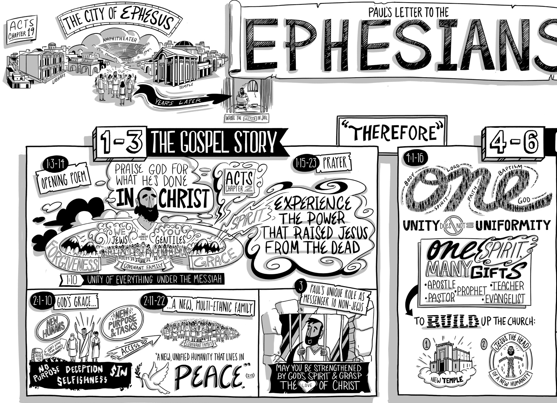

Message – Amelia koh-Butler Apart, can we find a new union?

Offering and Litany of Commitment:
Based on the 1985 Assembly document, “We are a Multicultural Church”. – Rev Dr Helen Richmond.

In Christ all human boundaries are swept away!
This we affirm.

Jesus Christ has mad peace between peoples of every race, culture and class!
We are witness bearers to this truth.

Our life together can be a foretaste of the reconciliation of all things in Christ!
We will seek to live as a sign and witness to the kingdom,
and a sign of hope within the Australian community.

As we move towards this new day we stand before God and our sisters and brothers
to face who we are and who we seek to be.
We hear the call of God to be open the gifts of all God’s people.

It will mean naming the sin of racism, even when it exits in the body of Christ.
We will work to create a community of justice and love.
None of God’s people are to be pushed to the fringes of our Church.
We will ensure that there are equitable rights in the use of Uniting Church properties;
access to our church’s resources;
full participation in decision-making in the councils of the church;
and pastoral care for all God’s people.

And when we are tempted to hold on to what we have from the past
and insulate ourselves from the hurts and struggles of each other.
God give us courage to step out of comfort and familiar zones.

May we celebrate the richness of our diversity, and unity which is your gift.
We go forward as your people carrying within us
the dream of God’s renewed and reconciled creation. Amen.

Empowering the Community’s Spirit

Song for Meditation Together https://youtu.be/lR1Hk0FVi_k

Prayers of the People - Rev Marion Gledhill

God, we know that Jesus healed many who were sick.
Everywhere he went people brought to him sick people,
hoping they could just touch his cloak to be healed.
Today there are many sick people in our world, too many in this pandemic.
And there are people who suffer from war.

We ask you to receive our prayer for healing – in the hotspots and trouble spots of the world.
We pray for people living in the hotspots of the pandemic –
in Indonesia, India, South Korea, Thailand, Southern Africa, and in Sydney.

We pray for people living in the world’s trouble spots, where often the pandemic rages as
well – in the resurgence of the Taliban in Afghanistan, in Myanmar, Haiti, Yemen, in the Tigray region of Ethiopia, and in Nigeria where there is great fear for abduction of school children.
We pray for displaced people everywhere seeking somewhere to lay their heads
but with very few nations willing to accept them.
Hear our prayer for hotspots and trouble spots here and in the world.
Hear our prayer for healing and for kindness in Australia and in the world.
Hear our prayer for those who are dear to us.

(the following is adapted from DIAKONIA prayer for July)
For we are certain that neither COVID-19 nor any other disease or violence or attacks,
or loneliness, or hunger, or fears of any kind, or social distance,
or things present, or things to come, will be able to come between us and the love of God.
God grant us the certainty that “nothing will be able to come between us and the love of God”,
for everybody in their own way.
God grant us deep inner peace and security,
in the profound certainty that You have a plan and You are always among us.
May everyone be strengthened and may we strengthen one another.
May we walk in the certainty that God is with us – that no matter what is to come, God is present.
Amen

Sending Song – We are the world (COVID Clarksville Children’s choir) https://youtu.be/J7711tVOzJQ

We have gathered, and we are sent to live out relationships that follow in the way of Jesus.
We live as neighbours not strangers, as brothers and sisters, not ‘them and us’, to celebrate the diversity of our human family, and the unity of our call to peace, love and justice.
May God our Creator, bless you with eyes to see the beauty of all people
and the glory of God’s creation.
May Christ Jesus fill you with love for your neighbour near and far.
May the Holy Spirit empower you with courage and passion
to shape communities of God’s liberating hope. Amen.

(Contributed by Dr Deidre Palmer, Assembly President)

Bible study - script from the video
Notes on the first half of the letter to the Ephesians

The story of how Paul came to the city of Ephesus is really interesting.
You can go read about it in Acts chapter 19.Ephesus was a huge city.
It was the epicentre of worship for most of the Greek and Roman gods.
For over two years, Paul had a really effective missionary presence there.
Lots of people became followers of Jesus.
Years later, after being imprisoned by the Romans, Paul wrote this letter.

The movement of thought in the letter divides into two really clear halves.
In the first half, Paul is exploring the story of the gospel,
how all history came to its climax, and Jesus,
and in his creation of this multi-ethnic community of his followers.
The second half of the letter is linked to the first by the word "therefore".
Here Paul explores how the gospel story should affect how we live
every part of our life story, personally, in our neighbourhoods and communities and in our families.
So let's dive in and we can see how Paul develops all of this.

Chapter 1 opens with a beautiful Jewish style poem where Paul praises God the Father
for the amazing things that he has done in Christ Jesus.
From eternity past, the father has purposed to choose and bless a covenant people.
Think here the family of Abraham and Genesis chapter 12 verses 1-3.
Through Jesus now, anyone can be adopted into that family.
Jesus's death covers our worst sins, our worse failures.
In Jesus, we find God's grace.
In fact, Paul says that grace has opened up a whole new way for us to understand every part of our lives.
He says, in chapter 1 verse 10, that God's purpose was to unify all things in heaven and on earth under Christ
which is a title that means Messiah.

God's plan was always to have a huge family of restored human beings who are unified in Jesus the Messiah.
This divine purpose became clear, Paul says, when we were first made into that family.
Here he is referring to ethnic Jews in the family of Abraham.
But then Paul talks about how you, and here he means non-Jews,
you all heard about Jesus and the salvation through him.
and you were also brought into this family by the work of the Holy Spirit.
Here he is referring to the events told in the stories of Acts about how God's Spirit
brought together Jew and non-Jew into one family in Jesus.
It is just like God promised to Abraham long ago.

Notice how in this poem Paul begins by talking about God the Father
but then about Jesus the Son and then, here the end, about the Spirit.
All three work together.

As Paul tells the story of the gospel. It is really cool.
After the poem, Paul responds with a prayer.
He prays that these followers of Jesus would not just know about, but personally experience, the power of the gospel,that they would be energized by the same power that raised Jesus from the dead
and placed him as the exalted head of the whole world.

In chapter 2, Paul goes back and elaborates on some key ideas from the poem in chapter one,
especially God's grace and this new multi-ethnic family of Jesus
He begins by retelling the story of how these non-Jewish Christians came to know Jesus.
Before hearing about Jesus they were physically alive but they were spiritually dead.
They were trapped in a purposeless life of selfishness and sin.
They were deceived by dark, spiritual forces of evil.
But, amazingly, God in his great love and mercy, he saved them.
He forgave all of their sins and he joined their lives to Jesus' resurrection life.
He brought them back to life, too.
So now, having been created as new human beings through Jesus,
they have the joy of discovering all of the new calling and purposes and tasks that God has set before them.
Not only have they been shown God's grace, they have also been invited into a new family.
Before hearing about Jesus, these non-Jewish people were not just cut off from God,
they were cut off from his covenant people, the family of Abraham, and for a really practical reason.
The commands of the Sinai covenant formed like a boundary line around the family.
They were like a barrier that kept most non-Jewish people away.
But in Jesus, the laws of the Torah have been fulfilled and the barrier is removed.
The two ethnic groups have become, as Paul puts it, "A new unified humanity that can live together in peace."

Paul goes on in chapter 3 to marvel at the unique role that he got to have
in spreading this good news to non-Jewish people. Even though he is in prison, he is thanking God for the chance he has had to see this covenant family grow so huge.
So Paul closes the first half of the letter with another prayer.
This time he prays that Jesus' followers would be strengthened by God's Spirit to simply grasp and comprehend the love that Christ has for his people.

