Eastwood Uniting Church 11 July, 2021
Green and Growing Season

Holy Communion
[please have a candle, a glass of water,
some bread/crackers and wine/juice prepared]
Leader: Rev Dr Amelia Koh-Butler Preacher: KyoungHee Cho (Student Minister)

_________________________________________________________________________________________

Creating Community with God

Lighting the candles John 8:12 요한복음 8:12 约翰福音 8:12

Jesus said to the people, “I am the light of the world. If you follow me,
you won’t have to walk in darkness, because you will have the light that leads to life.”
후에 예수님은 사람들에게 다시 말씀하셨다. “나는 세상의 빛이다. 나를 따르는 사람은 어두움에 다니지 않고 생명의 빛을 받을 것이다.”
耶稣又对众人说：“我是世界的光，凡跟从我的，必不会走在黑暗里，必要得到生命的光。”

Acknowledgement and Remembering Baptism

In Sydney, wherever we live, we are only a short way from the creeks, rivers, harbour and ocean beaches that hold stories of our heritage.
Today I am walking by the Parramatta River.
At this river, where the eels lie down to spawn,
we are thankful for the gift of life.
We remember the Darug-speaking people
who have nurtured life here from beyond our records of time.
We pray especially for elders and law-keepers,
and offer respect to all First People in this Land.
We stand with those of this River’s kin and skin.
We commit to behave as those who join in caring for
and listening to the signs of the sacred in this land.

Cooee Warami mittigar Come – you are welcome here
欢迎来到这里 오신 것을 환영합니다
nǐ hǎo 你好 Anyong haseyo 안녕하세요

Song of Praise Refiner's Fire https://youtu.be/RqpOJMYJvhU

A Prayer of Approach and The Lord’s Prayer

Our sins are forgiven. Thanks be to God!

Human and Divine – encountering Jesus Christ

A Time for Everyone – the story of Esther https://youtu.be/iWnMGSw97Wg
Sacred Story from Scripture – Mark 6:14-29

마가복음 6:14-29. 요한의 죽음. The Death of John the Baptist
¹⁴ King Herod heard of it, for Jesus’^{[a]} name had become known. Some were^{[b]} saying, “John the baptizer has been raised from the dead; and for this reason these powers are at work in him.” ¹⁵ But others said, “It is Elijah.” And others said, “It is a prophet, like one of the prophets of old.” ¹⁶ But when Herod heard of it, he said, “John, whom I beheaded, has been raised.”
¹⁷ For Herod himself had sent men who arrested John, bound him, and put him in prison on account of Herodias, his brother Philip’s wife, because Herod^{[c]} had married her. ¹⁸ For John had been telling Herod, “It is not lawful for you to have your brother’s wife.” ¹⁹ And Herodias had a grudge against him, and wanted to kill him. But she could not, ²⁰ for Herod feared John, knowing that he was a righteous and holy man, and he protected him. When he heard him, he was greatly perplexed;^{[d]} and yet he liked to listen to him. ²¹ But an opportunity came when Herod on his birthday gave a banquet for his courtiers and officers and for the leaders of Galilee. ²² When his daughter Herodias^{[e]} came in and danced, she pleased Herod and his guests; and the king said to the girl, “Ask me for whatever you wish, and I will give it.” ²³ And he solemnly swore to her, “Whatever you ask me, I will give you, even half of my kingdom.” ²⁴ She went out and said to her mother, “What should I ask for?” She replied, “The head of John the baptizer.”
²⁵ Immediately she rushed back to the king and requested, “I want you to give me at once the head of John the Baptist on a platter.” ²⁶ The king was deeply grieved; yet out of regard for his oaths and for the guests, he did not want to refuse her. ²⁷ Immediately the king sent a soldier of the guard with orders to bring John’s^{[f]} head. He went and beheaded him in the prison, ²⁸ brought his head on a platter, and gave it to the girl. Then the girl gave it to her mother. ²⁹ When his disciples heard about it, they came and took his body, and laid it in a tomb.

For the stories that describe the context of God’s love and grace - Thanks be to God!

Message – KyoungHee Cho Which do you want to choose?

Our lives are filled with a series of choices, aren’t they?
Today’s bible passage is the story of Herod, Herodias, Herodias’ daughter, Salome, and John the Baptist.
When we read this story, we usually think this is not our story, This is their story, and it is not related to me at all. But when we open our mind to the story, it has a lot of lessons for us.

In particular, the characters in the story are placed in a situation of choice. And their choices are based on what they believe is the most important thing for them. We will see their wrong choices and I do hope we don’t make the same mistakes in our faithful journeys.

First of all, Herod, the king of Galilee, heard about the growing reputation of Jesus, for Jesus’ name had become well known. In the previous verses, Jesus called the twelve and sent them out two by two. So, they went out and proclaimed that all should repent. That might be partly why Jesus was well known.

In reference to Jesus, some people said, “He is John the baptizer, who has been raised.” Others said, “He is Elijah.” Some people said, “He is a prophet.” These were the three prevailing opinions of the day about Jesus. Jesus was not yet reckoned as the Messiah in the popular mind.

Herod heard about Jesus and was reminded of John the Baptist. Herod feared John, knowing that he was a righteous and holy man. Herod even protected John. In the Bible we learn that John pointed out Herod’s faults.
¹⁸ For John had been telling Herod,
“It is not lawful for you to have your brother’s wife.”
Here, John is criticizing Herod’s marriage to Herodias!
Herod was greatly perplexed, and yet he liked to listen to John.
The problem for Herod is that it all ends there.

Herod heard of Jesus. He was reminded of John and his proclamation of the need to repent. And even though Herod’s conscience was bothering him, he was unwilling to face his sins honestly. He didn’t choose to repent.

What about you? Who do you think Jesus is for you?

Here, we need to understand that holding a high opinion of Jesus is not the same thing as having a faith.
Considering Jesus to be Elijah or one of the prophets, or, as we hear today, to be the greatest person ever to have lived, or the finest moral example of humanity, doesn’t necessarily bring us a step closer to faith.

You might think Jesus is the greatest person, or the greatest role model for our lives. But if that thought doesn’t lead us to believe that He is the Saviour for us, knowledge about him is nothing. Faith makes us turn to Him. Simply seeing him as a role model is not different to others’ opinions of him.

Let’s have a look at Herodias and, her daughter, Salome. Herodias hated John, wanted to kill him, and patiently waited for the most convenient time. And finally, the “strategic day” came for Herodias to put her plan into action.

It was the celebration of Herod’s birthday. Royal feasts were extravagant both in their display of wealth and in their provision of pleasure. There, Salome danced for her stepfather and other strangers.
At that time, men and women were not allowed even to eat together. The Jews would not have permitted a woman to dance before a group of men, and most Gentile mothers would have forbidden their daughters to dance to please men. But Salome was a part of her mother’s plan to get rid of John the Baptist, and she played her part well.

We often see on the news that hate leads to killing. It might be human nature. Here, Herodias overcame her husband and used her daughter to achieve what she wanted. She thought her status would be alright only if she got rid of John. Even though she knew how her husband, Herod, felt about John, she forced him to kill John the Baptist. Interestingly, just some years later, for some political reasons, Herod was deposed and he and his wife, Herodias, were banished and sent into exile.

We need to be careful that hatred doesn’t grow into evil desires.
We need to be aware about whether our heart’s desire is for God or for our own benefits.
We need to be cautious that our goal is not to win over those next to us or to use the ones we love for our own purposes.

Without fear of God, without submitting to Jesus, without conscience, our choices are unlikely to be different to Herodias.

Lastly, I am wondering what came to your mind when you heard “Whatever you ask me, I will give you, even half of my kingdom.” Yes, this promise recalls a similar promise of King Xerxes to Esther that resulted in the unmasking of Harman’s evil plot.

As an important text in Jewish ritual, the book of Esther has always been re-read during the festival season of Purim for Israelites. The Jews knew the story of Esther well.
And, like us, the audience of Mark would be reminded of Esther when they heard this phrase. Biblical scholars point out that Esther and Salome would be quite similar age. But their choices or learnings are totally different.

Salome learned from her mother to get rid of the person when he threatens you, regardless of whether he is righteous. But Esther learned from Mordecai that she could save her people with her choice.
It was a difficult choice, because she faced the real threat of death, like Xerxes’ previous wife, Vashti. I don’t want to talk about the second half of the book of Esther because it is also filled with cruel deaths. But choice in our faith is indispensable.

To conclude, Herod didn’t repent when he heard of Jesus.
Herodias and Salome killed a righteous person for their own benefits. But being ready to die, Esther made a choice to save her people and herself.
How do we influence people? For evil or for good? In your faith, which do you want to choose?
I hope you can make good choices to please God today and always. Amen

Empowering the Community’s Spirit

Offering Song– For such a time as this
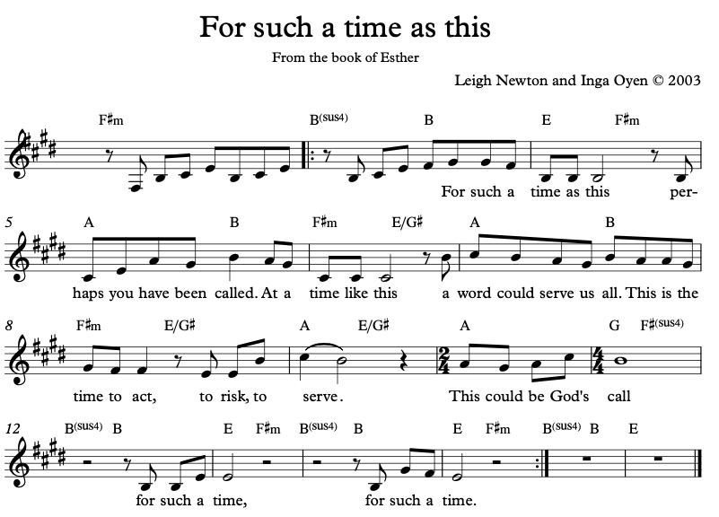

Thanksgiving Prayer and Prayers of the People

May we who are merely inconvenienced, remember those whose lives are at stake.
May we who have no risk factors remember those most vulnerable.
May those who have the luxury of working from home remember those who must choose between preserving their health or making their rent.
May those who have the flexibility to care for our children when schools close remember those who have no options.
May we who have to cancel a trip remember those who have no safe place to go.
May we who are losing our margin money in the tumult of the economic market remember those who have no margin at all.
May those who settle for quarantine at home remember those who have no home.
As fear grips our country, let us choose love during this time when we cannot physically wrap our arms around each other, let us find ways to be the loving embrace to God and our neighbour.
- Prayer by Cameron Wiggins Bellm
We hear the call to go forth and set the world on fire.
We embrace this metaphor because we believe our purpose is somehow linked
to helping others clarify and attain their purpose.
But how do we set our world on fire in this age of sickness, uncertainty, and fear.
How do we serve and lead when we are disconnected from each other
and the physical space that unifies our congregation. Who will show us how to press on?
Lives perish while the flames of leaders around us dance erratically in the blistering winds of change their lights flicker to near extinction their sparks, barely visible, struggle to light the way.
We cannot wait for them to lead.
Let us turn to our God and to the sacred light of the Holy Spirit that burns in each of us.
Let our spirits draw closer to each other in spite of the distance between us and march boldly into tomorrow.
Maybe it helps to imagine this time as a new pile of dry wood tossed onto our already steady
burning flames of purpose and love.
Let this fuel consume and quicken us for the greater good.
Shine on my friends may the bright flames of our spirits
burning in unison create a bonfire that sparks hope, ignites faith, illuminates love and lights the way.
In this uncertain age, a time when our brothers and sisters yearn for peace and light
we are called and stand ready to do learn to love in new ways and to do more than we did before.
To burn brighter. - adapted from a prayer by Ray Angle, Gonzaga University
God be with you
and also with you
Lift up your hearts
we lift them up to God
Let us give thanks to the Risen Christ
It is right to give our thanks and praise
God sang creation into being, imagining and imaging us into life.

How can we pray to this Creator?
You created and invited creation to choose Life with you!
From the first elements and cells,
you wove the threads of being into a tapestry of colour and vibrancy.
In all the simplicity and all the complexity you created humanity
in whom you could grow something beyond the measure of substance.
You created us for relationship, with you, with each other and with this world.
You created us to join in a joyous dance, but humanity chose self, rather than others.
Seeing loneliness and brokenness, competition and greed,
you sent your best self in Jesus the Christ, the Lord of the Dance,
to show us the steps and teach us to live again.
In lowly birth, in curious childhood, in public and private choices – he showed us to choose Life.
In his teachings and healings and choices, he became for us the Way, the Truth and the Life.
His persecution and death and resurrection showed us that choices have consequences,
but his resurrection shows us that to choose Christ is to choose Life.

How can we tell his story?
We say:
Christ has died
Christ is Risen
Christ will come again!

But we need God’s spirit to dwell within us to be able to tell this story.

So, keep coming upon us and these gifts, dear Holy Spirit,
fill us with the hope and faith that prompts us to keep choosing Love over hate.
Fill us to gather with those who have chosen you, with those who choose you now and with those who will choose you in times to come.

Why do we eat bread or crackers when we gather?

We gather together to remember that
on the night before Jesus died,
he had supper with his disciples.
He took bread, thanked you, as we have thanked you, broke the bread,
and gave the bread to his friends, saying:
This is my body given for you.
Each time you do this, remember me.

Why do we drink wine or juice when we gather?
After supper Jesus took the wine, thanked you for it,
and passed a cup of wine to his friends, saying:
This cup is the new promise God has made with you in my blood.
Each time you do this and drink from the cup, remember me.

This bread, earth-grown, hand-made, and heaven-blessed, is now for us the bread of life.
This cup, fruit of the vine, lifted in love and drunk with courage,
is now for us the cup of salvation.

How can we do this when we are apart?
The mystery of faith is that, in one place or in many,
we become God’s people through the sharing in the story of Christ
re-enacted in this meal.
This feast is not just for me, or for you, or even those whom we can see or hear.
The Lord invites all to his table and becomes the host of our lives
wherever and whenever we share his story.

Choose to share in God’s life! We choose the life God shares with us!
[Communion is shared]

Sending Song – O happy day https://youtu.be/tkS1LKARQvo

And may the Comm-Unity of God – Creator, Redeemer and Sustainer
Bless you now and always – AMEN

Additional resources for your devotional times this week:

I choose you https://youtu.be/Bw6IO51rBCE

Choices animation https://youtu.be/_HEnohs6yYw

A Mindful choice https://youtu.be/ZpjVT_vcHAs

Loch lomond https://youtu.be/nNo9Xo-vl5g

