Lunar New Year Celebration Service
農曆新年慶典崇拜
Sunday, 11 February 2024 (Transfiguration of Jesus)
2024年2月11日（農曆年初二、耶穌變像）

Welcome 환영 歡迎
恭喜發財 Wishing you prosperity and wealth in your spirit in heaven and earth

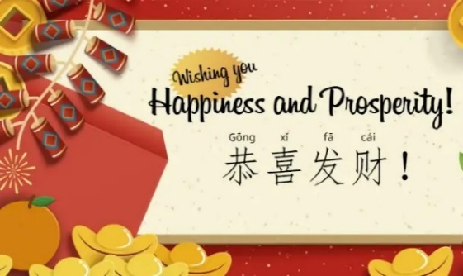

Acknowledgement of the First People of the Land
선주민 왈루메테갈 사람들의 땅임을 인정 承認土地上的原住民

We acknowledge the continuing sovereignty and rich cultural diversity of Australia’s First Peoples. We pay our respects to all Elders – past, present, and emerging – and to all First Peoples on whose lands we live and worship.

我们承认澳大利亚原住民的持续主权和丰富的文化多样性。我们向所有过去、现在和新兴的长老們以及我们在此處生活和崇拜的所有原住民长老致以敬意。

Call to worship 宣召
詩 篇 95:1-3
1來 啊 ， 我 們 要 向 耶 和 華 歌 唱 ，
向 拯 救 我 們 的 磐 石 歡 呼 ！
2 我 們 要 來 感 謝 他 ， 用 詩 歌 向 他 歡 呼 ！
3 因 耶 和 華 為 大 神 ， 為 大 王 ，
超 乎 萬 神 之 上 。

Psalm 95:1-3
1 Come, let us sing for joy to the Lord;
let us shout aloud to the Rock of our salvation.
2 Let us come before Him with thanksgiving
and extol Him with music and song.
3 For the Lord is the great God,
the great King above all gods.

Hymn – Jesus loves me 耶穌愛我
耶穌愛我！我知道，因有聖經告訴我，
幼小孩童祂牧養，他們軟弱主剛強。
副歌：主耶穌愛我！主耶穌愛我！
主耶穌愛我，有聖經告訴我。
耶穌愛我！永不變，雖我軟弱多疾病，
從今離罪得釋放，因主釘死十架上。(副歌)
耶穌愛我！捨生命，將我罪惡洗乾淨，
天堂恩門為我開，讓祂小孩走進來。(副歌)
1 Jesus loves me, this I know,
for the Bible tells me so.
Little ones to him belong;
they are weak, but he is strong.

Refrain:
Yes, Jesus loves me! Yes, Jesus loves me!
Yes, Jesus loves me! The Bible tells me so.

2 Jesus loves me he who died
heaven's gate to open wide.
He will wash away my sin,
let his little child come in. [Refrain]

3 Jesus loves me, this I know,
as he loved so long ago,
taking children on his knee,
saying, "Let them come to me." [Refrain]

Prayer – Tennyson

Gracious God, we thank you that in all cultures the Lunar New Year means a chance for a fresh start and a new beginning. We pray especially for all our people here as we celebrate Lunar New Year that we will come into a deeper knowledge of You. Thank you for putting the hunger for better times ahead and the hope for renewal of goodness and health into every heart for your purpose of motivating us to find Jesus who is our Redeemer and friend. Thank you that Jesus died on the cross to sweep clean our sins and make it possible for us to have new life in a relationship with Him that brings prosperity to our souls. In Jesus name we pray. Amen.

亲爱的上帝，我们感谢您，在所有文化中，农历新年意味着一个新的开始和崭新的起点。我们特别为我们的兄弟姐妹们庆祝农历新年祈祷，愿他们能更深刻地认识您。感谢您把美好时光的渴望和对善良和健康的更新的希望放在每個人的心中，以鼓励我们寻找耶稣，祂是我们的救赎主和朋友。感谢耶稣在十字架上为我们洗净罪恶，使我们有可能在与祂的关系中获得新生命，给我们的灵魂带来昌盛。我们奉耶稣的名祷告，阿门。

The Peace 평화 平安禮

The Peace of the Lord be with you. 주님의 평화가 여러분과 함께 하시길. 平安的主與你同在。
And also with you. 그리고 당신에게도 함께 하시길. 也與你同在。

What is Lunar New Year? 什麼是農曆新年?
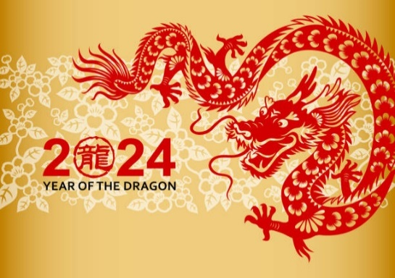
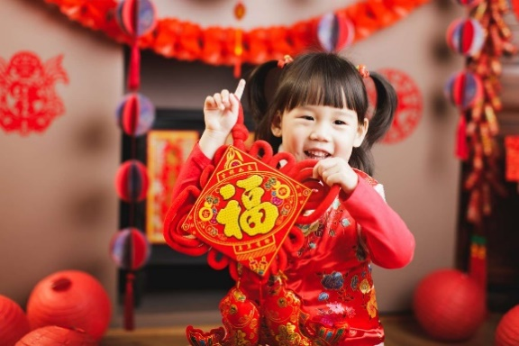
https://youtu.be/W5-xe-fAHws?t=13

Hymn presented by Chinese members – 華人會員獻唱

Song for the New Year: Let's celebrate the new year together and exchange blessings! Here's my congratulatory wish for you: "May happiness always accompany you! May you continue to reach new heights, never faltering in your spiritual journey. May you deepen your roots in the Lord, with all sins forgiven from this moment onward. May your body and mind be healthy and at ease, filled with humour and wit. May the Lord forever cherish and protect you, and may you always walk in the light! Let's enjoy the festivities as one family, with everyone, young and old, facing each day with smiles and peace!"

【賀歲歌】[粵語]
我地來賀歲，互獻祝福句；我要恭喜你，幸福永伴隨！
再創造高峰，靈程毋後退，更扎根主裡，從今百罪除，
身心康泰安舒，幽默風趣。 主永遠愛護你，主永遠庇佑你！
光明相隨！一家同歡， 老少平安個個笑面對！
Bible Reading – Jeremiah 29:10-14 Moling Chun 秦慕玲 ( in Cantonese )

This is what the LORD says: “You will be in Babylon for seventy years. But then I will come and do for you all the good things I have promised, and I will bring you home again. For I know the plans I have for you,” says the LORD. “They are plans for good and not for disaster, to give you a future and a hope. In those days when you pray, I will listen. If you look for me wholeheartedly, you will find me. I will be found by you,” says the LORD. “I will end your captivity and restore your fortunes. I will gather you out of the nations where I sent you and will bring you home again to your own land.”
New Living Translation

耶利米書 29:10-14
10 「耶和華如此說：為巴比倫所定的七十年滿了以後，我要眷顧你們，向你們成就我的恩言，使你們仍回此地。 11 耶和華說：我知道我向你們所懷的意念是賜平安的意念，不是降災禍的意念，要叫你們末後有指望。 12 你們要呼求我，禱告我，我就應允你們。 13 你們尋求我，若專心尋求我，就必尋見。 14 耶和華說：我必被你們尋見，我也必使你們被擄的人歸回，將你們從各國中和我所趕你們到的各處招聚了來，又將你們帶回我使你們被擄掠離開的地方。這是耶和華說的。

This is the words of the Lord 這是上帝的說話
Thanks be to God. 感謝上帝

Reflection on the Passages 설교 證道 Rev Seung Jae Yeon 廷承宰牧師

“Unspeakable Joy: Abiding in God”. "难以言喻的喜悦：在上帝里恒久不变"
Hymn – Shout to the Lord 詩歌 – 向主欢呼
主耶穌 我救主 我願一生 全心讚美
我願一生 全心讚美 祢奇妙全能的大愛
祢是我 安慰師 我避難所和力量
我的一切 每個氣息 永遠不住敬拜祢
向主歡呼 願全地揚聲唱
頌讚榮耀 能力歸於君王
眾山跪拜 眾海洋歡呼
歌頌主的聖名
我要歌頌 祢大能的作為
我要永遠愛祢 永遠要堅定
無一事物 能與祢的應許相比

My Jesus, my Saviour
Lord there is none like You
All of my days I want to praise
The wonders of Your mighty love

My comfort, my shelter
Tower of refuge and strength
Let every breath, all that I am
Never cease to worship You

Shout to the Lord all the Earth, let us sing
Power and majesty, praise to the King
Mountains bow down and the seas will roar
At the sound of Your name

I sing for joy at the work of Your hands
Forever I’ll love You, forever I’ll stand
Nothing compares to the promise I have In You

Offering and Dedication 봉헌 奉獻

Prayers of the People - 為萬人代禱 Rev Kiduk Huang ( In Korean) 黃基德牧師

Gracious God, please give your grace once again to all our neighbours in this world. May we remember the God who so loved the world that you gave us your one and only Son, and may we be all your people who fulfill your will.
May the rumours of war end and peace come to the whole world.
Have mercy on the many lives lost in the war between Russia and Ukraine, and may the suffering in Palestine come to an end as soon as possible.
May God guide us in a good way in the face of global warming and other climate issues, may God's grace be extended to all those who are struggling financially.
Even though Australia is a blessed nation, there are people who live a shady life.
May our society be able to share blessings with those in need.
May we all agree that a fully multicultural community where all people live together in harmony is God's will.
May we remember God’s will for us to build Eastwood Uniting Church here in Eastwood, and make us a church who move forward to fulfil God’s will every day.
Please remember those who first established your Church in this place, and bless the faithful saints who have devoted themselves to this church until now.
May we carry out the mission of this age that you have established as the Church, the body of Christ in the community.
Just as you loved our church, please comfort those who sick and lonely, and those who are economically disadvantaged and marginalised.
May we all fulfill the heart of Jesus, who told us to pray for God's will to be done on earth.
In Jesus' name we pray. Amen.

仁慈的神啊，請再次將你的恩典賜給生活在這個世界上的所有人。願我們記念那位愛世人，甚至將他的獨生子賜給我們的神，讓我們成為他所有成就他旨意的子民。
願戰爭的謠言停止，和平降臨全世界。
憐悯在俄烏戰爭中喪生的許多人，願巴勒斯坦的苦難早日結束。
願上帝在面對全球變暖和其他氣候問題時以良好的方式引導我們，願上帝的恩典擴展到所有在經濟上掙扎的人。
即使在這個幸福的澳大利亞社會中，也有人過著陰暗的生活。
願我們的社會可以分享祝福那些有需要的人。
願我們都同意成為一個完全多元文化的社會，讓所有人都和諧生活在一起，這是上帝的心願。
讓我們緊記上帝的旨意要在伊士活建立伊士活聯合教會，讓我們每天滿足神的心意向前走。
請記念那些第一次在這個地方建立你的教會的信徒，並祝福那些直到現在都獻身於這個教會的忠心聖徒。
願主的教會，即主的身體，在這個地區執行時代的使命。
求你安慰有疾病的人和孤獨者的心，好像你愛教會一樣。求你為經濟上處於不利地位和邊緣化的少數群體增添安慰。
願我們都應驗了耶穌的心，他告訴我們要為上帝的旨意在地上成就祈禱。
奉耶穌的名禱告。阿門。
Communion 성찬식 聖餐

Blessing – 祝福
May the God of hope fill you with all joy and peace as you trust in him,
so that you may overflow with hope by the power of the Holy Spirit.

願賜盼望的神，因你們的信把各樣的喜樂、平安充滿你們的心，
使你們藉著聖靈的能力大有盼望！

Announcements 광고 報告

Sydney Chinese Drum Art Troupe – Happy New Year 悉尼華人腰鼓歌舞團 - 「新年快樂」

Please move to the Main Hall for the Celebration Tea Party
請前去大禮堂參加慶祝茶會

